STOCK MARKET RESEARCH ANALYST INTERNSHIP
Weeks 1 to 6 Reports
Research design, financial analysis, technical analysis, risk, economics and a final recommendation
Prepared by
Nayana Sheelavant
Date
19th October, 2026
Contents
Week 1: Market Analysis and Research Design (Information Technology sector)
Week 2: Financial Statement Analysis and Valuation Modeling (Microsoft)
Week 3: Technical Analysis and Chart Pattern Evaluation (Microsoft and JPMorgan Chase)
Week 4: Risk Assessment and Portfolio Diversification Strategy
Week 5: Analysis of Economic Indicators and Market Trends
Week 6: Investment Recommendation and Comprehensive Report
Market data refers to the close of 16 October 2026 unless a different date is stated. These reports are learning exercises and are not investment advice.

Week 1 Report: Market Analysis and Research Design
Sector studied: Information Technology, US-listed, benchmarked to the S&P 500
Prepared by: Nayana Sheelavant Date: 19th October, 2026

1. Executive Summary
This report is a research plan for analysing the Information Technology (IT) sector of the US stock market. It explains why I chose the sector, what the first round of public research shows, which indicators I will track, which methods I will use and why, how the work is split across seven days, and what could go wrong.
I chose IT because it is where the numbers are most extreme right now. According to FactSet's 16 October 2026 Earnings Insight, IT companies in the S&P 500 are on course for third-quarter earnings growth of 65.1%, compared with 29.0% for the whole index. Revenue growth is 40.6% against 12.6%. Global chip sales passed $1 trillion for the year through August, the first time ever. At the same time, the 10-year Treasury yield is about 5.24%, its highest in more than two decades, and the Federal Reserve raised rates in September. A sector with that much growth and that much rate pressure is a good place to practise research design.
The plan uses a hybrid design. Macro indicators set the context, fundamental and valuation analysis tests whether prices are supported by earnings, technical analysis reads trend and momentum, and scenarios turn the evidence into a view. I specify eight indicators, three of them core, and I show worked examples of the calculations with real numbers so that every step can be checked.
Sector at a glance | Reading | Source and date
IT earnings growth, Q3 2026 (year on year) | 65.1% (S&P 500: 29.0%) | FactSet, 16 Oct 2026
IT revenue growth, Q3 2026 | 40.6% (S&P 500: 12.6%) | FactSet, 16 Oct 2026
IT net profit margin, Q3 2026 | 32.3% (5-year average 25.9%) | FactSet, 16 Oct 2026
Global semiconductor sales, August 2026 | $159.7 billion, up 144.3% in a year | SIA, 5 Oct 2026
S&P 500 forward 12-month P/E | 19.0 (10-year average 19.1) | FactSet, 16 Oct 2026
10-year Treasury yield | About 5.24% | Associated Press, 9 Oct 2026
S&P 500 and Nasdaq Composite, year to date | +14.1% and +17.7% | Associated Press, 9 Oct 2026
Microsoft capital spending, FY2026 | $115.9 billion, up 79.6% | Microsoft Form 8-K, 29 Jul 2026
Table 1. Sector facts used in this plan.

Requirement checklist
Task requirement | Where addressed
Conduct initial research on a chosen sector using public resources | Section 3 (sector research with data); Section 7 (sources)
Identify and list at least three key market indicators | Section 5 (eight indicators with current readings; three core)
Clear explanation of research methodologies selected | Section 6 (six methods with rationale and limitations)
Structured plan with analysis methods and timelines | Sections 8 and 9 (eight steps with worked examples; day-by-day tasks)
Step-by-step approach to analysing market trends | Section 8
Potential challenges and proposed solutions | Section 11 (each with a real example)
Table 2. Mapping of requirements to sections.

2. Research Objectives, Scope and Hypotheses

2.1 Objective
To design a repeatable plan for analysing the current condition and likely direction of the IT sector, and to define the methods, data and indicators that will be used.

2.2 Research questions
- RQ1 (Trend): Is the IT sector in an uptrend, downtrend or consolidation relative to the broad market, and how durable is that trend?
- RQ2 (Drivers): Which macroeconomic and sector-specific factors explain most of its recent price movements?
- RQ3 (Valuation): Are valuations supported by earnings growth and the direction of analyst estimates?
- RQ4 (Scenarios): What could change the trend over the next 6 to 12 months, and which indicators would give early warning?

2.3 Testable hypotheses
Hypothesis | How it will be tested | Evidence available already
H1: IT sector returns are negatively sensitive to rising long-term real yields. | Rolling 36-month correlation and regression of monthly sector returns on changes in the 10-year real yield (FRED series DFII10). | The 10-year yield rose from about 4.05% in October 2025 to about 5.24% in October 2026, yet the Nasdaq is up 17.7% this year. Sensitivity may be weaker than usual, which is worth testing.
H2: Rising earnings estimate revisions precede relative outperformance over 1 to 3 quarters. | Compare net revision breadth with the next 3-month return relative to the S&P 500. | IT growth estimate for Q3 rose from 63.8% on 30 Sep to 65.1% on 16 Oct, with all reporting IT companies beating estimates so far.
H3: Growth in hyperscaler capital spending supports semiconductor earnings, and a slowdown is an early warning for them. | Track quarterly capex against semiconductor sales and index performance. | Microsoft capex grew 79.6% in FY2026, and global chip sales are up 144.3% year on year in August.
Table 3. Hypotheses.

2.4 Scope and exclusions
- In scope: US-listed IT sector companies (S&P 500 constituents, with the XLK sector fund as a tradable proxy), a 10-year history for valuation and trend work, and a 6 to 12 month forward view.
- Out of scope this week: recommendations on individual stocks (Week 6), full company valuation models (Week 2) and non-equity assets (considered in Week 4).

3. Sector Selection and Initial Research

3.1 Why Information Technology
- It is growing faster than anything else. Q3 earnings growth of 65.1% is the second-highest of the eleven sectors, behind only Energy (127.6%). Revenue growth of 40.6% is the highest of all sectors.
- It is profitable. The net profit margin of 32.3% compares with 14.9% for the S&P 500 and with an IT five-year average of 25.9%.
- Analysts are optimistic. The bottom-up target price implies upside of 26.8% for IT, the largest of any sector, against 20.3% for the S&P 500. About 69% of ratings on IT stocks are Buy.
- It is data rich. Quarterly filings, estimate trackers, industry sales data and market prices are all freely available.

3.2 Sector structure and growth by industry
Industry group | Illustrative companies | Q3 2026 earnings growth | Q3 2026 revenue growth | Main drivers
Semiconductors and equipment | Nvidia, Micron, Broadcom, AMD, Applied Materials | 130% | 83% | AI chips and memory demand, inventory cycles, export controls
Technology hardware, storage and peripherals | Apple, Dell | 39% | 36% | Product cycles, AI servers, tariffs
Electronic equipment and components | Jabil | 39% | 24% | Supply chain, data centre build-out
Software | Microsoft, Oracle, Salesforce, ServiceNow | 14% | 18% | Subscriptions, cloud, AI monetisation
IT services | Accenture | 5% | 4% | Enterprise IT budgets
Table 4. IT sector by industry. Source: FactSet Earnings Insight, 16 Oct 2026. Communication equipment (revenue growth 25%) is also part of the sector.
A classification caveat. Popular talk about "tech stocks" spans more than one official sector. Alphabet and Meta Platforms sit in Communication Services and Amazon sits in Consumer Discretionary, while payment networks such as Visa and Mastercard were moved from IT to Financials in the 2023 reclassification. The research will use the official IT sector as its definition and treat those companies as a related group when tracking AI spending.

3.3 What the data says about the sector today
The first lesson from the numbers is that the sector's growth is narrow. The table separates the headline from the underlying picture.
Measure | Headline | Excluding the biggest drivers | Gap
S&P 500 Q3 earnings growth | 29.0% | 20.0% without Micron and Nvidia | 9.0 points from two companies
IT sector Q3 earnings growth | 65.1% | 24.4% without semiconductors | 40.7 points from one industry
"Magnificent 7" Q3 earnings growth | 33.2% | 7.5% without Nvidia and Meta | 25.7 points from two companies
Other 493 S&P 500 companies | 27.7% | Not applicable | Close to the index rate
Table 5. Concentration of earnings growth. Source: FactSet, 16 Oct 2026. Gap is calculated as headline minus the adjusted figure.
The second lesson is about demand. Global semiconductor sales were $159.7 billion in August 2026, up 8% on July and 144.3% on August 2025 (the SIA reports a three-month moving average). That was the 18th straight month of growth. Sales were $403.3 billion in the second quarter, up 35.1% on the first quarter, and the SIA expects more than $1.6 trillion for 2026, compared with $791.7 billion in 2025. The Americas grew fastest, up 180.9% year on year in August.
The third lesson is about spending. Microsoft spent $115.9 billion on property and equipment in FY2026, against $64.6 billion in FY2025, which is a rise of 79.6% and about 35% of its revenue. That money is the revenue of the chip and server makers above, which is the link H3 tests.
The fourth is about prices and rates. The S&P 500 forward 12-month P/E is 19.0, below its five-year average of 19.8 and its ten-year average of 19.1 by a small margin, but the trailing P/E is 26.0 against a ten-year average of 23.6. The 10-year Treasury yield is about 5.24%. Inflation was 3.7% in September, and Brent crude was about $105 a barrel on 9 October. In early October the Dow was still about 5% below its August record while the Nasdaq made new highs, so leadership is narrow.

4. Key Factors Affecting Stock Market Movements
Prices reflect expectations about future cash flows and the rate used to discount them. I grouped the factors by how they reach IT prices and added the current evidence, so that each factor has a measurable reading.
Category | Factor | How it affects IT stocks | Current evidence
Macroeconomic | Interest rates and policy | Higher discount rates cut the present value of distant earnings, which hits growth stocks hardest | Fed funds 3.75% to 4.00% after the 16 Sep hike; 10-year about 5.24%
Macroeconomic | Inflation and growth | Inflation shapes the rate path; growth drives IT budgets | CPI 3.7% (Sep); US GDP +2.2% (Q2); ISM PMI 54.5 (Sep)
Sector | AI and cloud capital spending | Spending by cloud providers is revenue for chip, server and network makers | Microsoft capex $115.9 billion, up 79.6%
Sector | Semiconductor cycle | Demand and inventory swing between shortage and glut | Chip sales $159.7 billion in Aug, up 144.3% in a year
Policy | Trade controls, tariffs, regulation | Export limits and tariffs restrict markets or add cost | Export controls and tariffs remain open issues
Company | Earnings, guidance and margins | Results against expectations drive short-term prices | IT surprise +5.5% in aggregate; all reporting IT companies beat so far
Market behaviour | Sentiment and positioning | Crowded positions amplify moves | Narrow leadership; Nasdaq +17.7% year to date against Dow +7.5%
Table 6. Factors, mechanisms and current evidence.

5. Key Market Indicators
The task requires at least three indicators. I specify eight in two tiers. The core tier must be analysed in full. The supporting tier provides cross-checks. Each has a current reading, so that the plan starts from real data and the later days only need to update and extend it.
# | Indicator | Current reading | Source and date | What the reading suggests
1  Core | Forward P/E (S&P 500; sector value read from the FactSet sector chart) | 19.0; 5-year average 19.8; 10-year average 19.1. Trailing 26.0 against 23.6 | FactSet, 16 Oct 2026 | Forward valuation is about average, trailing is 10% above average
2  Core | EPS growth and revisions | IT Q3 growth 65.1%, up from 63.8% on 30 Sep; CY2026 S&P growth 32.8%; CY2027 16.0% | FactSet, 16 Oct 2026 | Revisions positive. Growth expected to slow sharply in 2027
3  Core | 10-year Treasury yield and real yield | About 5.24%; roughly 1.5% above 3.7% CPI | AP, 9 Oct; BLS, 14 Oct 2026 | Headwind. Highest in over two decades
4  Supporting | Hyperscaler capital spending | Microsoft $115.9 billion in FY2026 (FY2025: $64.6 billion) | Microsoft 8-K, 29 Jul 2026 | Strong demand signal for suppliers
5  Supporting | Semiconductor sales | $159.7 billion in Aug; +144.3% year on year; 18th monthly rise | SIA, 5 Oct 2026 | Hardware side of the AI trade is broad
6  Supporting | Relative strength and breadth | Nasdaq +17.7% against S&P 500 +14.1% year to date; Dow +7.5% | AP, 9 Oct 2026 | Tech leading, but breadth is narrow
7  Supporting | ISM Manufacturing PMI | 54.5 (Aug 54.6); new orders 55.3 (year ago 48.7); prices paid 77.9 | ISM, 1 Oct 2026 | Demand good, cost pressure high
8  Supporting | VIX and sentiment | VIX 15.84 on 9 Jul (latest verified); 2025 average 18.93; 69% of IT ratings are Buy | FRED; FactSet | Low fear, high optimism. To be refreshed
Table 7. Indicator set with readings. The VIX reading is the latest I could verify and will be updated on Day 5.

5.1 Worked examples with these indicators
Calculation | Working | Result and meaning
Forward P/E against the 10-year average | 19.0 / 19.1 - 1 | -0.5%: the index is priced at its long-run norm on forward earnings
Trailing P/E against the 10-year average | 26.0 / 23.6 - 1 | +10.2%: on past earnings the index looks expensive, so the case for fair value rests on earnings growth coming through
Real yield (rough) | 5.24% - 3.7% | 1.54%: a positive real return on risk-free money, which is a real change from 2020 to 2021
Earnings yield against the 10-year yield | 1 / 19.0 = 5.26%, against 5.24% | About zero extra yield for owning stocks over Treasuries. The cushion is thin
Relative strength, Nasdaq against S&P 500, year to date | 1.177 / 1.141 - 1 | +3.2%: the Nasdaq has outperformed the S&P 500 by about 3.2% this year
Growth from capital spending | 115.948 / 64.551 - 1 | +79.6%: Microsoft capex growth, the H3 input
Price-to-earnings-growth, Microsoft, reported EPS | 29.5 / 31.6 growth | 0.93
Price-to-earnings-growth, Microsoft, excluding OpenAI effect | 30.6 / 22 growth | 1.39: the same stock looks cheaper or dearer depending on which earnings are used
Table 8. Worked examples.

5.2 Interpretation guide
- Valuation: a forward P/E in the top decile of its ten-year range leaves little margin for error, but is not a timing signal by itself.
- Earnings: rising estimates with a high share of positive surprises supports a trend. Falling estimates while prices rise is a more fragile, valuation-driven rally.
- Rates: a sustained rise in the real yield is a headwind. A fall is supportive but may reflect weak growth, so it is checked against the PMI.
- Confirmation rule: a conclusion is robust only when at least three of the five scorecard categories (Appendix A) agree.

6. Research Methodologies and Rationale
No single method answers all four questions, so the plan combines complementary methods.
Method | How it will be applied | Why it was selected | Known limitation
Top-down macro analysis | Start with growth, inflation, rates, dollar and policy and trace the effect to the sector (Table 6) | Answers RQ2. Rates matter greatly for the sector | Macro relationships change over time
Bottom-up fundamental analysis | Review revenue, margins, EPS growth and revisions for the sector and key companies; compare valuation with history | Answers RQ3. Earnings drive long-term returns | Depends on estimates, which get revised
Technical analysis | Moving averages, relative strength, momentum and drawdown | Answers RQ1. Shows what investors are actually doing | Backward-looking and partly subjective
Quantitative analysis | Rolling correlations and a regression of sector returns on market returns and yield changes (H1) | Gives objective, testable evidence | Correlation is not causation; sample-sensitive
Sentiment and positioning | VIX, investor surveys, share of Buy ratings, breadth | Detects crowded trades | Noisy over short periods
Scenario analysis | Bull, base and bear cases with triggers linked to indicators | Answers RQ4. Handles uncertainty | Judgement-based probabilities
Table 9. Methods and rationale.
The analysis works as a funnel: macro sets the environment, fundamentals test whether prices are justified, technical and sentiment evidence shows current behaviour, quantitative tests check assumed relationships, and scenarios combine everything into a view with explicit triggers. Using several methods lowers the chance of confirmation bias, because a conclusion must survive evidence from different angles.

7. Data Sources and Data Quality
Data needed | Primary source | Cross-check | Reliability note
Company financials | SEC EDGAR (10-K, 10-Q, 8-K) | Yahoo Finance, Nasdaq | Primary filings are authoritative. Earnings releases are unaudited
Sector valuation and earnings | FactSet Earnings Insight (free weekly report) | S&P Dow Jones Indices, fund fact sheets | Check each source's definition of "forward"
Rates, inflation, growth | FRED, BLS, BEA, Federal Reserve | US Treasury, IMF World Economic Outlook | Official data is later revised; record release dates
Prices and technical indicators | TradingView or StockCharts; Yahoo Finance | Fund issuer price history | Use dividend-adjusted prices for returns
Semiconductor industry | SIA and WSTS monthly sales | Company results | Three-month moving averages; published with a lag
Business activity | ISM Manufacturing PMI | S&P Global PMI | Survey-based; directional
Sentiment | VIX via FRED; AAII survey | FactSet ratings data | Use only to confirm other evidence
Table 10. Data sources.
- Verify every key figure against at least two sources or the primary filing.
- Log the date, source, definition and series code for every number in a data log.
- Snapshot raw data before cleaning so results can be reproduced.
- Separate facts, estimates and opinions in the write-up.

8. Step-by-Step Approach to Analysing Market Trends
The eight steps below run in order. Each step names the method, a worked example with real numbers, the output and the research question it answers.

Step 1: Define the universe and take a baseline
Define the sector as the S&P 500 IT sector, using XLK and the semiconductor index as proxies. Record sector weight, forward P/E, one-year and five-year returns, each with a date. Worked example: on 9 October 2026 the S&P 500 stood at 7,811.54, up 966.04 points or 14.1% for the year, and the Nasdaq Composite at 27,366.17, up 17.7%. Those two lines are the baseline the later steps are compared against.
Output: baseline data table.

Step 2: Classify the trend (RQ1)
Calculate price against the 50-day and 200-day averages, 3-, 6- and 12-month returns, the relative strength ratio and the drawdown from the 52-week high. Worked example, Microsoft: the close of $529.05 compares with a 50-day average of $503.91 and a 200-day average of $434.78. Distance from the 50-day is 529.05 / 503.91 - 1 = +5.0%, and from the 200-day is 529.05 / 434.78 - 1 = +21.7%. Because price is above both and the 50-day is above the 200-day, the rule gives "uptrend". The drawdown from the 52-week high of $553.72 is 529.05 / 553.72 - 1 = -4.5%.
Output: trend classification with a chart.

Step 3: Assess valuation (RQ3)
Compare the sector's forward P/E with its own ten-year range and with the S&P 500, then add PEG ratio and free cash flow yield. Worked example: for the index, forward 19.0 against a ten-year average of 19.1 is -0.5%, while trailing 26.0 against 23.6 is +10.2%. For Microsoft, the free cash flow yield is $67.0 billion divided by a market value of about $3,929 billion, which is 1.7%, well below the 5.24% Treasury yield.
Output: valuation table.

Step 4: Analyse earnings and fundamentals (RQ3)
Collect revenue growth, margins, EPS growth and the direction of revisions, and record capex guidance from the largest cloud providers. Worked example: IT earnings growth of 65.1% includes 40.7 points from semiconductors. Without that industry the figure is 24.4%. Recording both numbers prevents a single industry from masking the rest of the sector.
Output: fundamentals summary and capex tracker.

Step 5: Link to the macro environment (RQ2)
Run the H1 test: regress monthly sector returns on market returns and changes in the 10-year real yield over rolling 36-month windows; review the ISM PMI and the dollar. Worked example: a 1 percentage point rise in the discount rate cuts the present value of $100 due in 10 years from $42.2 (at 9%) to $38.6 (at 10%), which is -8.7%. For $100 due in two years the fall is only -1.8% (from $84.2 to $82.6). That gap is why far-future earnings, and growth stocks, are more sensitive to rates.
Output: correlation and regression table.

Step 6: Measure sentiment and breadth
Record VIX, survey readings, the share of stocks above their 200-day average and the top-five against rest comparison. Worked example: the Nasdaq outperformed the S&P 500 by 3.2% (1.177 / 1.141 - 1) year to date, while the Dow was only up 7.5%, so gains are concentrated.
Output: sentiment and breadth panel.

Step 7: Build the indicator scorecard
Score five categories as -1, 0 or +1 against thresholds set in Appendix A before looking at the data, then weight and sum. The worked scoring below uses the readings in Table 7 as a demonstration.
Category | Weight | Evidence | Score | Contribution
Valuation | 20% | Forward P/E at its ten-year average; trailing 10% above | 0 | 0.00
Earnings | 25% | IT growth 65.1%, revisions rising, all reporters beating | +1 | +0.25
Rates and macro | 20% | 10-year 5.24%, Fed hiking, CPI 3.7%; PMI 54.5 helps | -1 | -0.20
Trend and momentum | 20% | Nasdaq +17.7% against S&P +14.1%; Microsoft above averages | +1 | +0.20
Sentiment | 15% | Low VIX, 69% Buy ratings, narrow breadth | 0 | 0.00
Composite | 100% |  |  | +0.25
Table 11. Worked scorecard (first pass, October 2026). Composite = sum of weight x score.
A composite of +0.25 on a scale of -1 to +1 reads as mildly positive. Two categories are positive, one is negative and two are neutral, so the positive evidence outweighs the negative, but the confirmation rule (at least three of five agreeing) is not fully met. The honest label is therefore "mildly positive, not confirmed": a constructive but rate-sensitive view.
Output: completed scorecard.

Step 8: Develop scenarios and a monitoring plan (RQ4)
Define the bull, base and bear scenarios (Section 10) with triggers tied to indicators, and set a review schedule: weekly for prices, yields and sentiment; monthly for chip sales and the PMI; quarterly for earnings and capex.
Output: scenario table and monitoring calendar.

9. Timeline: Daily Tasks
The work is organised as seven working days. Each day has defined tasks and a checkpoint output, so that progress can be checked at the end of every day. Days start by reviewing the previous day's data log and end by saving a dated snapshot of any new data.
Day | Tasks | Checkpoint output
Day 1 | Confirm the sector and benchmark. Write the four research questions and three hypotheses. Set up the data log with columns for metric, value, date, source, definition and series code. Define the scorecard thresholds before seeing any data. | One-page scope note, empty data log, threshold table
Day 2 | Read the latest FactSet Earnings Insight, the SIA monthly release and the IMF outlook. Record the sector structure and the growth rate of each industry group. Record 15 time-stamped sector facts, such as the 65.1%, 40.6% and 32.3% figures. | Sector fact sheet with 15 logged figures
Day 3 | Collect core indicators 1 to 3: forward and trailing P/E, EPS growth and revisions, and the 10-year and real yields from FRED. Calculate premiums to ten-year averages. | Valuation and rates table with calculations shown
Day 4 | Collect supporting indicators 4 to 6: capex from company filings, semiconductor sales from the SIA, and relative strength and breadth from a charting site. Calculate growth rates and the relative strength ratio. | Capex tracker, chip sales table, relative strength chart
Day 5 | Collect indicators 7 and 8 (ISM PMI, VIX) and the latest CPI. Run the H1 correlation and regression in a spreadsheet. Check whether the sensitivity to yields is stable. | Regression table and macro summary
Day 6 | Fill the scorecard and apply the weights. Draft the bull, base and bear scenarios. Write the challenges and solutions table, each with a real example from the data. | Completed scorecard, scenario table, challenges table
Day 7 | Assemble the document. Add figures and tables, cross-check every number against the data log, check each source link, proofread and format. | Final report ready for submission
Table 12. Day-by-day task plan.
The tools are spreadsheet software for the data log and regression, a charting site for price charts, a simple reference list for sources and a word processor for the final report.

10. Scenario Framework
Scenarios turn the analysis into a view of the next 6 to 12 months. The triggers are the conditions the monitoring plan will watch. They are a framework for reasoning, not a forecast.
Scenario | Narrative | Indicator conditions | Implication for the sector
Bull | AI spending keeps converting to earnings, rates stabilise and breadth widens. | IT growth estimate stays above 50%; capex guidance maintained; 10-year yield below 5%; chip sales growth above 100% year on year | Trend continuation, with valuation supported by earnings
Base | Growth continues but slows. Valuation absorbs news without a large re-rating. | Revisions flat to mildly positive; yield between 4.8% and 5.4%; leadership narrow | Range-bound, with wide differences between stocks
Bear | AI spending slows or fails to earn adequate returns, or rates rise further. | Estimates falling; capex guidance cut; yield above 5.5%; VIX above 25; chip sales growth fading quickly | Valuation compression and drawdown, hardest in the most expensive names
Table 13. Scenarios.

11. Potential Challenges and Proposed Solutions
Challenge | Real example from this research | Proposed solution
Concentrated growth hides the typical stock | IT earnings growth of 65.1% falls to 24.4% without semiconductors; S&P 500 growth falls from 29.0% to 20.0% without Micron and Nvidia | Report headline and adjusted numbers side by side; track breadth
Data revisions | US Q2 GDP was first reported at 1.5% and revised to 2.2% in the third estimate | Time-stamp data; record whether a figure is preliminary
Different vendors, different numbers | Two sites publish an RSI of 71.2 and 62.4 for Microsoft on the same date | Show both; state which source is used and why
One-off gains distort profit | Alphabet booked a $98 billion gain and Amazon a $53.4 billion gain in Q2; Microsoft reported EPS of $17.95 against $17.28 without its OpenAI effect | Compare reported and adjusted measures; use free cash flow as a cross-check
Narrative bias | AI is the dominant story, so sources lean one way | Apply the confirmation rule; look for contradicting evidence
Unstable relationships | The 10-year yield rose about 1.2 points in a year while the Nasdaq rose 17.7%, which weakens the usual link | Use rolling windows and report ranges, not one number
Limits of free data | The sector forward P/E is shown only in a FactSet chart, not as text | Read the chart value manually and log it; cross-check with fund fact sheets
Unexpected events | Brent crude near $105 and a Fed meeting on 28 October could change the picture quickly | Maintain triggers and update the base case when one is hit
Table 14. Challenges, examples and solutions.

12. Expected Outputs, Limitations and Ethics
- Outputs: a time-stamped baseline, a trend classification, valuation and earnings assessments, hypothesis test results, a completed scorecard, three scenarios and a monitoring calendar that feeds Weeks 2 to 6.
- Limitations: public data and simple tools cannot match institutional research. Samples are small, scenarios are judgemental and a single industry (semiconductors) is driving much of the sector's numbers.
- Ethics: only public information is used, sources are credited, and nothing here is investment advice.

13. Conclusion
The IT sector is a rich and timely subject. It is growing very fast, it earns high margins, and it is exposed to the highest long-term interest rates in more than twenty years. The plan gives each research question a method, a data source, a dated reading and a day on which it will be handled. The worked examples show that the main numbers can be reproduced by anyone with the sources, and the challenges table shows where the traps are, especially in the way semiconductors dominate the sector's headline growth. The result is a plan that can be carried out on schedule and that sets up the company, technical, risk and macro work in the following weeks.

Appendix A: Indicator Scorecard Template
Each category is scored -1, 0 or +1 against thresholds fixed before the data is examined. The composite is the weighted sum between -1 and +1.
Category | Indicators used | Weight | Threshold for +1 and -1
Valuation | Forward P/E percentile and premium to S&P 500 | 20% | +1: below 40th percentile of ten-year range. -1: above 85th percentile
Earnings | EPS growth, revision breadth, capex guidance | 25% | +1: revisions positive and rising. -1: revisions negative
Rates and macro | 10-year real yield trend, PMI, dollar | 20% | +1: real yield falling with PMI above 50. -1: real yield rising sharply
Trend and momentum | Moving averages, relative strength, breadth | 20% | +1: price above 50- and 200-day averages with improving breadth. -1: below both
Sentiment | VIX, surveys, share of Buy ratings | 15% | +1: elevated fear with stabilising prices. -1: extreme complacency
Table A1. Scorecard template. Weights total 100%.

Sources
- FactSet, Earnings Insight, 16 October 2026: https://advantage.factset.com/hubfs/Website/Resources%20Section/Research%20Desk/Earnings%20Insight/EarningsInsight_101626.pdf
- Semiconductor Industry Association, "Year-to-Date Global Semiconductor Sales Top $1 Trillion Through August", 5 October 2026: https://www.semiconductors.org
- ISM, Manufacturing PMI Report, September 2026: https://www.ismworld.org/supply-management-news-and-reports/reports/ism-pmi-reports/pmi/september/
- Associated Press via La Nacion, "How major US stock indexes fared Friday 10/9/2026": https://www.lanacion.com.ar/usa/how-major-us-stock-indexes-fared-friday-1092026-nid09102026/
- US Bureau of Labor Statistics, Consumer Price Index, September 2026: https://www.bls.gov/cpi/
- US Bureau of Economic Analysis, GDP third estimate, second quarter 2026: https://www.bea.gov/news/2026/gdp-third-estimate-industries-corporate-profits-state-gdp-and-state-personal-income-2nd
- Microsoft Corporation, Form 8-K, Exhibit 99.1, 29 July 2026: https://www.sec.gov/Archives/edgar/data/0000789019/000119312526323632/msft-ex99_1.htm
- Federal Reserve Bank of St. Louis, FRED (VIXCLS, DGS10, DFII10): https://fred.stlouisfed.org
- Federal Reserve, FOMC statement, 16 September 2026: https://www.federalreserve.gov/monetarypolicy/files/monetary20260916a1.pdf
- Yahoo Finance, Microsoft (MSFT) quote, 16 October 2026: https://finance.yahoo.com/quote/MSFT/
- AlgovestIQ, MSFT technical analysis (moving averages and RSI): https://www.algovestiq.com/stock/msft/technicals
- Financhill, MSFT technical analysis (RSI): https://financhill.com/stock-price-chart/msft-technical-analysis

Week 2 Report: Financial Statement Analysis and Valuation Modeling
Company studied: Microsoft Corporation (NASDAQ: MSFT), fiscal years 2024 to 2026
Prepared by: Nayana Sheelavant Date: 19th October, 2026

1. Introduction and Choice of Company
Week 1 ended with a plan for studying the technology sector, so this week I picked one company from it and went through its numbers properly. I chose Microsoft. It is one of the largest listed companies in the world, it sits in the software and cloud part of the sector I wrote about, and its latest annual results came out only in late July, so the data is fresh. Microsoft's fiscal year runs from 1 July to 30 June, which means FY2026 covers July 2025 to June 2026.
The aim is straightforward. I want to read the income statement, balance sheet and cash flow statement together, decide how healthy the business really is, and then build a basic valuation to see whether a share price of $529.05 (the 16 October 2026 close) looks reasonable. Everything is in US dollars. Where I had to make a judgement call, I say so in the text.

2. Sources and How I Handled the Data
Item | Source | Note
FY2026 and FY2025 statements | Microsoft Q4 FY2026 earnings release, Form 8-K Exhibit 99.1, filed 29 July 2026 (SEC EDGAR) | The statements in the release are marked unaudited, so the final annual report could differ slightly.
FY2024 figures | Microsoft FY2024 Form 10-K, as originally reported | Microsoft has recast some prior-period items for presentation, so tiny differences are possible.
Share price, market value, beta, analyst targets | Yahoo Finance, close of 16 October 2026 | Prices move daily. Microsoft reports again on 28 October 2026.
Forward P/E | Benzinga quote page | Third-party estimate, used only as a cross-check.
Interest rate backdrop | Federal Reserve statement of 16 September 2026; CNBC; Charles Schwab | Used for the risk-free rate and the discount rate.
Table 1. Data sources.
I checked the headline numbers (revenue of $331.8 billion, net income of $133.7 billion, diluted EPS of $17.95) against the filing and several news reports. They agreed.

3. Business Snapshot
Microsoft reports three segments. The table shows how each did in FY2026.
Segment | Revenue ($B) | Growth | Operating income ($B) | Operating margin
Productivity and Business Processes | 140.0 | +15.9% | 83.9 | 59.9%
Intelligent Cloud | 137.8 | +29.7% | 57.0 | 41.3%
More Personal Computing | 54.1 | -1.1% | 14.4 | 26.6%
Total | 331.8 | +17.8% | 155.2 | 46.8%
Table 2. FY2026 segment results. Source: Microsoft Form 8-K, 29 July 2026.
Intelligent Cloud is where the growth is. Azure and other cloud services passed $100 billion in annual revenue for the first time, up 41% for the year and 43% in the fourth quarter. Commercial remaining performance obligation, which is signed business not yet recognised as revenue, rose 84% to $678 billion, and Microsoft 365 Copilot has more than 30 million paid seats. The weak spot is More Personal Computing: Windows OEM and devices fell 7% and Xbox content and services fell 10% in the fourth quarter.

4. Income Statement Analysis
($ billion unless stated) | FY2024 | FY2025 | FY2026
Revenue | 245.1 | 281.7 | 331.8
Gross margin | 171.0 | 193.9 | 225.5
Gross margin % | 69.8% | 68.8% | 67.9%
Research and development | 29.5 | 32.5 | 35.6
R&D as % of revenue | 12.0% | 11.5% | 10.7%
Operating income | 109.4 | 128.5 | 155.2
Operating margin | 44.6% | 45.6% | 46.8%
Net income | 88.1 | 101.8 | 133.7
Net margin | 36.0% | 36.1% | 40.3%
Diluted EPS ($) | 11.80 | 13.64 | 17.95
Revenue growth | +15.7% | +14.9% | +17.8%
Operating income growth | +23.6% | +17.4% | +20.8%
Net income growth | +21.8% | +15.5% | +31.3%
EPS growth | +21.9% | +15.6% | +31.6%
Table 3. Income statement summary. Growth for FY2024 uses FY2023 as the base.
Revenue growth picked up to 17.8% in FY2026 from 14.9% a year earlier. That is a lot for a company already past $300 billion in sales.
The margin story is more interesting than the growth. Gross margin slipped from 69.8% to 67.9% over two years because the cost of running cloud and AI services is rising faster than the revenue they bring in (cost of service and other revenue grew about 27% in FY2026). Even so, operating margin rose to 46.8%, because operating expenses grew only about 7%, and research spending fell from 12.0% to 10.7% of revenue. The fourth quarter also carried costs from a voluntary retirement programme and impairment charges on Xbox, which Microsoft called out itself.
Net income rose 31%, well ahead of the 21% growth in operating income, and I wanted to understand the gap. It comes from "other income", which swung from a loss of $4.9 billion in FY2025 to a gain of $10.7 billion in FY2026, mostly from investments. Microsoft shows the effect of its OpenAI stake separately: stripping it out, net income is $128.8 billion (up 22%) and diluted EPS is $17.28 rather than $17.95. The fourth quarter also included a $3.2 billion gain on an investment in Anthropic. So the operating business grew around 21% to 22%, and the extra growth in reported profit is investment gains that may not repeat.
Two smaller points. The effective tax rate was 19.4% in FY2026, up from 17.6% in FY2025 and 18.2% in FY2024, which took a little off earnings growth. And diluted shares were almost flat (7,453 million against 7,465 million), so EPS growth is coming from real profit, not from buybacks shrinking the share count.

5. Balance Sheet Analysis
($ billion) | 30 Jun 2025 | 30 Jun 2026 | Change
Cash and short-term investments | 94.6 | 76.8 | -18.7%
Accounts receivable | 69.9 | 80.9 | +15.7%
Property and equipment, net | 205.0 | 313.1 | +52.7%
Equity and other investments | 15.4 | 36.3 | +136.0%
Total assets | 619.0 | 758.4 | +22.5%
Accounts payable | 27.7 | 42.4 | +53.0%
Total debt (current and long-term) | 43.2 | 40.3 | -6.6%
Short-term unearned revenue | 64.6 | 73.0 | +13.0%
Other long-term liabilities | 45.2 | 65.1 | +44.1%
Total liabilities | 275.5 | 316.0 | +14.7%
Stockholders' equity | 343.5 | 442.4 | +28.8%
Table 4. Selected balance sheet items. Source: Microsoft Form 8-K, 29 July 2026.
The headline is property and equipment, up about $108 billion in a single year. That is the data centre build-out showing up on the balance sheet. Equity grew faster than liabilities because Microsoft kept most of its profit (retained earnings rose by about $90.5 billion), and the equity and other investments line more than doubled, which fits the OpenAI and Anthropic positions.
Liquidity is still comfortable, though a bit thinner. The current ratio fell from 1.35 to 1.23, helped down by a jump in accounts payable, which is what you would expect when suppliers are building you data centres. Debt is small. Total debt is $40.3 billion against $76.8 billion of cash and short-term investments, so Microsoft is in a net cash position of about $36.5 billion, and debt to equity is only 0.09.
One thing I want to flag. "Other long-term liabilities" rose by about $20 billion to $65.1 billion. I believe this includes lease obligations for data centres, but the earnings release does not break it out, so I cannot confirm it. If it is right, the real commitments Microsoft has taken on are bigger than the debt line suggests. I come back to this in the limitations.

6. Cash Flow Analysis
($ billion unless stated) | FY2024 | FY2025 | FY2026
Net cash from operations | 118.5 | 136.2 | 182.9
Additions to property and equipment (capex) | 44.5 | 64.6 | 115.9
Free cash flow (operations less capex) | 74.1 | 71.6 | 67.0
Free cash flow margin | 30.2% | 25.4% | 20.2%
Capex as % of revenue | 18.1% | 22.9% | 34.9%
Operating cash flow / net income | 1.35 | 1.34 | 1.37
Free cash flow / net income | 0.84 | 0.70 | 0.50
Dividends plus buybacks | 39.0 | 42.5 | 48.7
Dividends plus buybacks as % of free cash flow | 52.7% | 59.3% | 72.7%
Table 5. Cash flow summary. Sources: Form 8-K (FY2025, FY2026) and Form 10-K (FY2024).
Cash generation from the business itself is excellent. Operating cash flow rose 34% to $182.9 billion, which is 1.37 times net income, so the profit is real cash and not accounting. The problem sits one line lower. Capital spending jumped 80% to $115.9 billion, about 35% of revenue compared with 18% two years ago.
The result is that free cash flow fell 6.5% to $67.0 billion in a year when net income grew 31%. Free cash flow as a share of net income has gone from 0.84 to 0.70 to 0.50. If I had to pick one finding from this whole exercise, this is it. Microsoft is more profitable than ever on paper, but each extra dollar of profit now leaves less cash behind because so much is being poured into capacity. It is also still paying out about 73% of free cash flow through dividends and buybacks. That is fine while operating cash flow keeps growing, but it leaves less room if growth slows.
Depreciation is the follow-on effect. It rose from $29.4 billion to $38.5 billion (about 31%) and will keep climbing as the new data centres come into service, which is why I let the margin drift down in the forecast later.
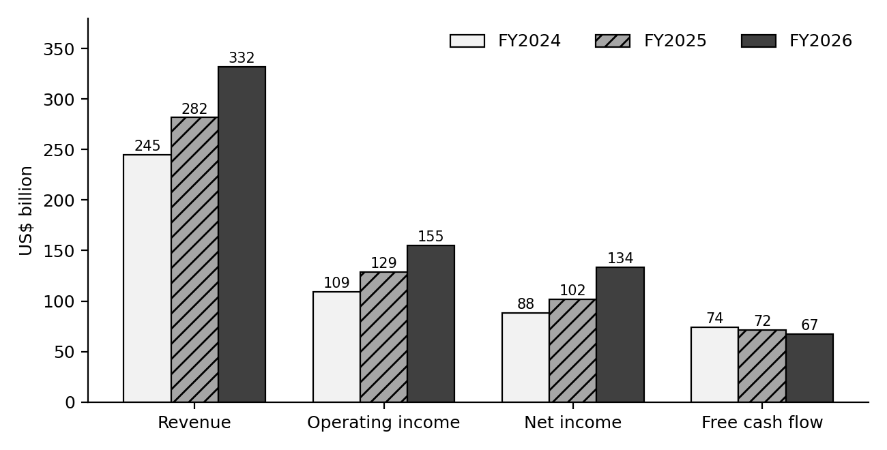
Figure 1. Revenue, operating income, net income and free cash flow, FY2024 to FY2026 (US$ billion). Free cash flow is the only line that fell.

7. Ratio Summary
Area | Ratio | FY2024 | FY2025 | FY2026 | My reading
Profitability | Gross margin | 69.8% | 68.8% | 67.9% | Drifting down as AI costs rise
 | Operating margin | 44.6% | 45.6% | 46.8% | Rising, helped by cost control
 | Net margin | 36.0% | 36.1% | 40.3% | Flattered by investment gains
 | Return on equity | n/a | 33.3% | 34.0% | High and stable
 | Return on assets | n/a | 18.0% | 19.4% | High, even with a larger asset base
Efficiency | Asset turnover | n/a | 0.50 | 0.48 | Slipping as assets grow faster than sales
Liquidity | Current ratio | 1.27 | 1.35 | 1.23 | Comfortable but falling
Leverage | Debt to equity | 0.17 | 0.13 | 0.09 | Very low
 | Liabilities to equity | 0.91 | 0.80 | 0.71 | Improving
Cash | Free cash flow margin | 30.2% | 25.4% | 20.2% | The weak spot
 | Free cash flow / net income | 0.84 | 0.70 | 0.50 | Falling every year
Table 6. Key ratios. Return ratios use average equity and average assets, so they start in FY2025.
A quick DuPont check helps explain return on equity. For FY2026, ROE of 34.0% equals a net margin of 40.3%, multiplied by asset turnover of 0.48, multiplied by an equity multiplier of 1.75. Profit margin is doing nearly all the work. Turnover is low and leverage is modest, so the return does not rely on borrowing.

8. Valuation Model

8.1 Why I used a discounted cash flow
I used a discounted cash flow (DCF) model because it forces me to write down what I believe about growth, margins, spending and risk, and then shows what those beliefs are worth. I did not build a comparable-company table. I could not verify current peer figures to the standard I wanted, and I would rather leave it out than fill it with numbers I cannot stand behind. Instead I cross-check the DCF with Microsoft's own multiples in Section 8.7.

8.2 Discount rate
Discount rates are a hard topic this year. The Federal Reserve raised its target range to 3.75% to 4.00% on 16 September 2026, its first increase since 2023, and the 10-year Treasury yield moved to about 5%, the highest in roughly two decades. That pushes up the risk-free rate, and with it the required return on any stock.
Input | Value | Basis
Risk-free rate | 5.0% | 10-year Treasury yield, about 5% in mid-September 2026
Equity beta | 1.10 | Yahoo Finance, 5-year monthly
Equity risk premium | 4.5% | My assumption, within the usual 4% to 6% range
Cost of equity | 9.95% | Risk-free rate + beta x equity risk premium
Pre-tax cost of debt | 5.3% | My assumption, slightly above Treasuries for a top-rated borrower
Tax rate | 19% | Close to the FY2026 effective rate of 19.4%
Weight of debt / equity | 1.0% / 99.0% | Debt of $40.3B against market value of about $3.9 trillion
WACC | 9.9% | Used as the base discount rate
Table 7. Discount rate build-up.
Because debt is about 1% of total capital, the WACC is almost the same as the cost of equity. The number is sensitive to my risk-free rate and equity risk premium, so I show a sensitivity table later rather than pretending there is one right answer.

8.3 Forecast assumptions
The forecast runs ten years, FY2027 to FY2036, because a company growing in the mid-teens cannot sensibly be put on a steady growth rate after only five years. Growth fades gradually, then a terminal growth rate takes over. I calculate free cash flow to the firm as operating profit after tax, plus depreciation, minus capital spending. I do not add back stock-based compensation, so it is treated as a real cost. That is more conservative than the free cash flow Microsoft reports.
Assumption | Base case | Reasoning
Revenue growth | 16% in FY2027, fading to 5% by FY2036 | Microsoft's guidance for the first quarter of FY2027 implies growth of about 16%. The fade reflects the law of large numbers.
Operating margin | 45% throughout | Below the FY2026 level of 46.8% because depreciation will keep rising.
Tax rate | 19% | In line with recent history.
Depreciation and amortisation | 13% of revenue rising to 16%, then 15% | FY2026 was 11.6%. It rises as the new assets are put to use.
Capital spending (all-in) | 38% of revenue in FY2027, falling to 18% by FY2036 | FY2026 was 34.9% on cash capex alone. I set it higher because some data centre capacity is funded through finance leases, which this line does not capture.
Terminal growth | 3.5% | Roughly long-run nominal growth of the economy.
Working capital | No net change | Microsoft collects cash from customers before it delivers service, so working capital is not a drag. I left it out for simplicity.
Table 8. Base case assumptions.
Fiscal year | Revenue | Operating income | After-tax operating profit | Depreciation | Capex | Free cash flow to firm
2027 | 385 | 173 | 140 | 50 | 146 | 44
2028 | 443 | 199 | 161 | 64 | 155 | 71
2029 | 505 | 227 | 184 | 78 | 156 | 106
2030 | 570 | 257 | 208 | 91 | 154 | 145
2031 | 639 | 287 | 233 | 102 | 153 | 182
2032 | 706 | 318 | 257 | 113 | 155 | 215
2033 | 769 | 346 | 280 | 123 | 158 | 246
2034 | 827 | 372 | 301 | 132 | 161 | 272
2035 | 877 | 394 | 320 | 136 | 162 | 293
2036 | 920 | 414 | 335 | 138 | 166 | 308
Table 9. Base case forecast ($ billion).
Look at the first forecast year. Free cash flow to the firm is only $44 billion in FY2027, below the $67 billion Microsoft produced in FY2026, because spending rises faster than profit. It then climbs as capital spending flattens against growing revenue. Most of the value in the model comes from the later years.

8.4 Results by scenario
Discounting the base case at 9.9% gives an enterprise value of about $2.95 trillion. Adding cash and short-term investments ($76.8 billion) and equity investments ($36.3 billion), and subtracting debt ($40.3 billion), gives an equity value of about $3.02 trillion. Dividing by 7,443 million diluted shares gives $406 per share. About 66% of that enterprise value sits in the terminal value, which is typical for a growth company and a reminder to treat the answer as a range.
Scenario | Revenue growth | Operating margin | Capex % of revenue | Terminal growth | Value per share | Versus $529.05
Bear | 13% fading to 4.0% | 42% | 40% to 20.0% | 3.0% | $257 | -51%
Base | 16% fading to 5.0% | 45% | 38% to 18.0% | 3.5% | $406 | -23%
Bull | 18% fading to 6.0% | 47% | 36% to 16.5% | 4.0% | $538 | +2%
Weighted (25/50/25) |  |  |  |  | $402 | -24%
Table 10. Scenario results at a WACC of 9.9%.
The bear case assumes growth slows faster, margins fall to 42% and spending stays heavy. The bull case assumes growth holds up longer, margins reach 47% and capital spending comes down sooner. The 25/50/25 weights are my own judgement.
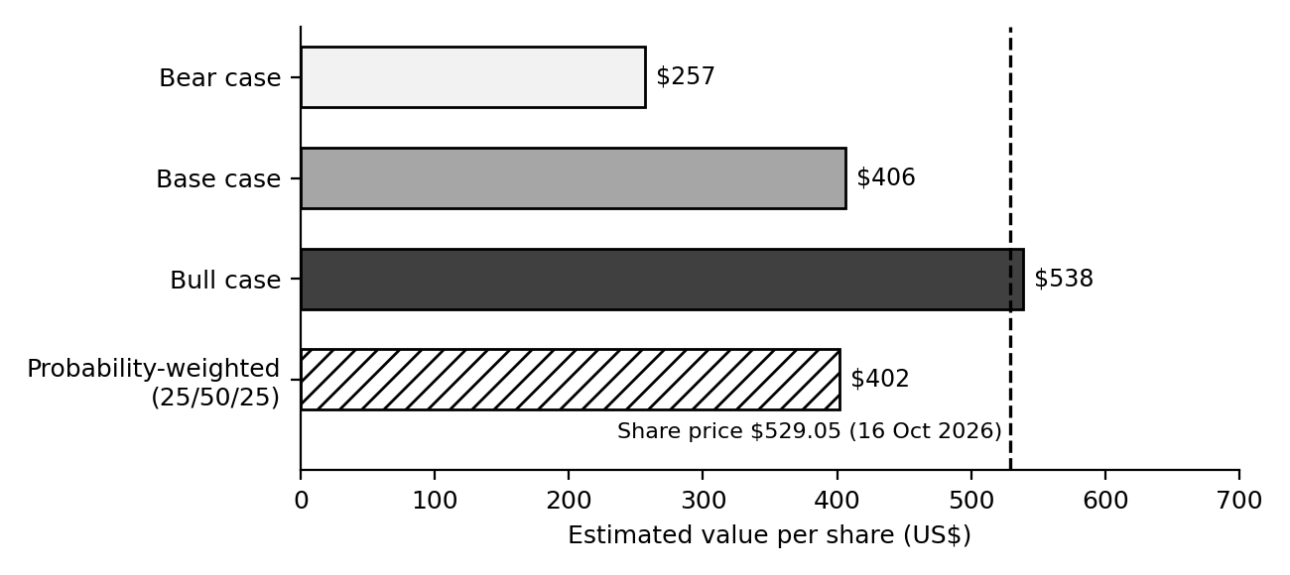
Figure 2. DCF value per share by scenario compared with the 16 October 2026 share price.

8.5 Sensitivity
WACC \ Terminal growth | 2.5% | 3.0% | 3.5% | 4.0% | 4.5%
8.5% | $470 | $500 | $536 | $580 | $635
9.0% | $429 | $453 | $482 | $517 | $559
9.5% | $393 | $414 | $437 | $465 | $498
9.9% | $369 | $386 | $406 | $430 | $457
10.5% | $337 | $351 | $367 | $385 | $407
11.0% | $313 | $325 | $339 | $354 | $372
Table 11. Base case value per share for different discount rates and terminal growth rates.
Moving the discount rate by one percentage point moves the answer by roughly $60 to $100 per share. That is the honest takeaway: a DCF is a way of organising assumptions, not a measuring instrument.

8.6 What the share price implies
I also ran the model backwards. Keeping my base-case operating forecast, the current price of $529.05 is justified only if the discount rate is about 8.6%, which is well below the 9.9% I built from today's yields. Alternatively, keeping the 9.9% discount rate, the price needs revenue to grow about 31% faster than my base case in every year. Put differently, the market is paying for something close to my bull case, or it is using a lower discount rate than I am.

8.7 Cross-check with multiples
Measure | Value at $529.05 | Comment
Market value | $3.93 trillion | 7,427 million shares outstanding
Enterprise value | $3.89 trillion | Market value less cash, plus debt
Price to earnings (reported) | 29.5x | On FY2026 diluted EPS of $17.95
Price to earnings (excluding OpenAI effect) | 30.6x | On non-GAAP EPS of $17.28
Forward P/E (third-party estimate) | about 27x | Benzinga
Enterprise value to revenue | 11.7x
Enterprise value to operating income | 25.1x
Price to free cash flow | 58.7x | Free cash flow yield of 1.7%
Price to book | 8.9x
Dividend yield | 0.74% | Annual dividend of $3.92 per share
Table 12. Valuation multiples.
A free cash flow yield of 1.7% is thin next to a 10-year Treasury paying about 5%. Investors are clearly paying for growth, not current cash. For context, analyst price targets on Yahoo Finance average about $599 with a range from $440 to $870, so the street is more optimistic than my base case. The difference comes down to the same two levers: lower discount rates and faster growth.

8.8 Worked examples
A valuation can feel like a black box, so here are the key calculations written out, using the numbers from earlier in this section.
Calculation | Working | Result
Cost of equity | 5.0% + 1.10 x 4.5% | 9.95%
WACC | 99.0% x 9.95% + 1.0% x 5.3% x (1 - 19%) | 9.89% (rounded to 9.9% in the model)
FY2027 revenue | $331.8B x 1.16 | $384.9B
FY2027 operating income | $384.9B x 45% | $173.2B
FY2027 after-tax operating profit | $173.2B x (1 - 19%) | $140.3B
FY2027 depreciation and capex | 13% x $384.9B = $50.0B; 38% x $384.9B = $146.3B | Net spending of $96.2B
FY2027 free cash flow to firm | $140.3B + $50.0B - $146.3B | $44.1B
Present value of FY2027 cash flow | $44.1B / 1.099 | $40.1B
Terminal value (end of FY2036) | $307.9B x 1.035 / (9.9% - 3.5%) | $4,979B
Present value of terminal value | $4,979B / 1.099^10 | $1,937B
Enterprise value | $1,013B (ten years of cash flow) + $1,937B | $2,950B
Equity value per share | ($2,950B + 76.8 + 36.3 - 40.3) / 7.443B shares | $406
Table 13. Valuation worked through step by step (base case).
Ratio | Working (FY2026, $ billion) | Result
Current ratio | 207.710 / 168.825 | 1.23
Return on equity | 133.749 / ((442.387 + 343.479) / 2) | 34.0%
Free cash flow | 182.935 - 115.948 | $67.0B
Free cash flow as share of net income | 67.0 / 133.7 | 0.50
Price to earnings | $529.05 / $17.95 | 29.5x
Free cash flow yield | 67.0 / 3,929 | 1.7%
Earnings yield against the 10-year Treasury | 1 / 29.5 = 3.4%, against about 5.0% to 5.2% | Earnings yield is well below the risk-free yield
Table 14. Ratio calculations written out.

9. Findings and Conclusion
Microsoft is a very high quality business. Revenue is growing at 18%, operating margin is near 47%, cash from operations is larger than profit, debt is small and returns on equity are above 30%. Nothing in the three statements worries me about solvency or earnings quality.
What does concern me is how much of that profit is being converted into cash. Free cash flow fell while earnings jumped, because capital spending is now about a third of revenue. My DCF, which rests on today's higher interest rates, values the shares at about $406 in the base case (a range of $257 to $538) against a price of $529.05. I read that as the stock being fully valued: the price already assumes the bull case, or a lower discount rate than I think is prudent. That is not a call to sell. A strong business can stay expensive for a long time, and Microsoft has surprised on the upside before. It is a reason to be careful about how much to pay.
For the weeks ahead, three things will move the picture. First, the earnings report on 28 October 2026, where capital spending guidance and Azure growth matter most. Second, the Fed meeting the same day. Third, whether capital spending starts to flatten against revenue, which is the single thing my model needs for free cash flow to recover.

10. Assumptions and Limitations
- Unaudited data. FY2026 figures come from the earnings release, not the final 10-K. The FY2024 column comes from the original 10-K and may differ slightly from recast figures.
- Date of the price. I used the 16 October 2026 close. The valuation gap will change when earnings are released.
- Finance leases. Capital spending in the cash flow statement excludes finance leases. I tried to cover this by setting the capex assumption higher, and by deducting only reported debt, but lease obligations could mean the model slightly overstates value.
- Investment gains. Gains on OpenAI and Anthropic stakes are not part of the operating forecast. I include the investments in equity value at their book value, which may be more or less than market value.
- Discount rate. The risk-free rate is at a roughly 19-year high. If yields fall, value per share rises quickly (see Table 11).
- Simplifications. Constant margin, no working capital change and a constant share count. None of these are exactly right.
- Peer comparison. I did not include a comparable-company analysis, as explained in Section 8.1.
- Not advice. This is a learning exercise. It is not a recommendation to buy or sell any security.

11. Sources
- Microsoft Corporation, Form 8-K, Exhibit 99.1 (earnings release for the quarter and year ended 30 June 2026), 29 July 2026: https://www.sec.gov/Archives/edgar/data/0000789019/000119312526323632/msft-ex99_1.htm
- Microsoft Corporation, Form 10-K for fiscal year 2024 (SEC EDGAR): https://www.sec.gov/edgar
- Yahoo Finance, Microsoft (MSFT) quote, close of 16 October 2026: https://finance.yahoo.com/quote/MSFT/
- Benzinga, Microsoft (MSFT) quote and key statistics: https://www.benzinga.com/quote/MSFT
- Federal Reserve, FOMC statement of 16 September 2026: https://www.federalreserve.gov/monetarypolicy/files/monetary20260916a1.pdf
- CNBC, "10-year Treasury yield climbs back to 5% after Fed hikes rates", 16 September 2026: https://www.cnbc.com/2026/09/16/treasury-yield-bond-market-fed-decision.html
- Charles Schwab, "Fed Hikes: What's Next for Treasury Yields?": https://www.schwab.com/learn/story/fed-hikes-whats-next-treasury-yields
- Redmondmag, "Microsoft Tops $90B Quarterly Revenue as Azure Hits $100B Annual Milestone", 30 July 2026: https://redmondmag.com/articles/2026/07/30/microsoft-tops-90b-quarterly-revenue.aspx

Week 3 Report: Technical Analysis and Chart Pattern Evaluation
Stocks studied: Microsoft (software and cloud) and JPMorgan Chase (banking)
Prepared by: Nayana Sheelavant Date: 19th October, 2026

1. Introduction
Last week I asked what Microsoft is worth. This week I am asking a different question: what is the price itself doing, and what might that say about what comes next? Technical analysis does not look at earnings or balance sheets. It looks at price and volume history and tries to read the behaviour of buyers and sellers from it.
The task asks for at least two stocks from different industries. I picked Microsoft and JPMorgan Chase. Microsoft is a technology company whose shares tend to be sensitive to interest rates and to expectations about AI spending. JPMorgan is the largest US bank, earning most of its money from lending, trading and investment banking, so its drivers are different. Both are huge and heavily traded, which tends to give cleaner charts than thinly traded shares do.
I should be clear about my method. I used public charting and data sites rather than my own charting software, so the indicator values below are the ones those sites published. Different sites calculate some indicators slightly differently, and I point out where that mattered. The figures I built are level maps made from reported price levels, not raw price charts.

Data used and its dates
Item | Value | Source | As of
MSFT close | $529.05 (down 1.9% on the day) | Yahoo Finance | 16 Oct 2026
MSFT 52-week range | $349.20 to $553.72 | Yahoo Finance | 16 Oct 2026
MSFT 50-day and 200-day averages, MACD, RSI | See Table 4 | AlgovestIQ and Financhill | 14 Oct 2026 close
JPM price | About $336 | AskTraders, Beinsure | 13 Oct 2026
JPM all-time high and correction low | $366.50 and $325.87 | OANDA | 13 Aug and 1 Oct 2026
JPM moving averages | See Table 5 | TradingView-based review (mexc), OANDA | 5 Oct 2026 and earlier
JPM RSI and MACD | 59.9 and +0.62 | Investing.com | 9 Oct 2026
Table 1. Key data points and when they were recorded.
The dates matter. The Microsoft indicators were recorded two days before the last close, and the JPMorgan ones come from several days around its earnings report. I have not mixed them up, but a reader should not treat every number as a 16 October reading.

2. The Indicators I Used
Indicator | What it measures | How I read it | Weakness
Simple and exponential moving averages (50-day, 200-day) | Average closing price over the period. The exponential version weights recent days more. | Price above a rising 200-day average suggests a long-term uptrend. A 50-day average crossing above the 200-day is called a golden cross, and below it a death cross. | They lag. By the time a cross appears the move has usually happened.
Relative Strength Index, RSI (14) | Speed of recent gains against losses, on a scale of 0 to 100. RSI = 100 - 100 / (1 + average gain / average loss). | Above 70 is often called overbought and below 30 oversold. In strong trends it can stay high for weeks. | A high reading is not a sell signal on its own.
MACD (12, 26, 9) | The 12-day exponential average minus the 26-day, with a 9-day signal line. | MACD above its signal line is bullish momentum, below is bearish. The gap (histogram) shows whether momentum is building or fading. | Gives false signals when prices move sideways.
Support and resistance | Price areas where buying or selling has repeatedly appeared. | A break through resistance on heavy volume is a stronger signal than one on light volume. | Levels are judgement calls, not exact.
Fibonacci retracement | Common pullback depths, such as 38.2%, 50% and 61.8% of a prior move. | Pullbacks that stall near a retracement level are often watched as possible turning points. | Widely followed, but partly self-fulfilling and not scientific.
Volume | Number of shares traded. | Moves on rising volume carry more weight than moves on falling volume. | Needs context. Earnings days spike volume.
Table 2. Indicators and how I use them.

2.1 Worked examples of the calculations
Calculation | Working | Result and meaning
RSI (illustrative inputs) | Average gain 1.10, average loss 0.70 over 14 days. RS = 1.10 / 0.70 = 1.571. RSI = 100 - 100 / (1 + 1.571) | 61.1: firm momentum, not overbought. Microsoft's published readings of 62.4 to 71.2 are in the same area
Distance from the 50-day average, Microsoft | $529.05 / $503.91 - 1 | +5.0%: medium-term trend up
Distance from the 200-day average, Microsoft | $529.05 / $434.78 - 1 | +21.7%: stretched above the long-term base
Distance from the 52-week high, Microsoft | $529.05 / $553.72 - 1 | -4.5%: close to resistance
Recovery from the low, Microsoft | $529.05 / $349.20 - 1 | +51.5%: a sharp V-shaped rebound
Correction from the high, JPMorgan | $325.87 / $366.50 - 1 | -11.1%: a normal correction inside an uptrend
Distance to the 50-day average, JPMorgan | $351.55 / $336.00 - 1 | +4.6% needed to reach the confirmation level
Table 3a. Indicator calculations with real prices.
The next table shows how the pattern targets in Section 3 are calculated. The prices are made up for illustration and are not forecasts.
Pattern | Illustrative prices | Calculation | Target
Head and shoulders | Head $110, neckline $90 | Head height = 110 - 90 = $20. Target = neckline - height = 90 - 20 | $70
Double top | Two peaks at $200, trough at $180 | Height = 200 - 180 = $20. Target = trough - height = 180 - 20 | $160
Ascending triangle | Resistance $50, first low $44 | Widest height = 50 - 44 = $6. Target = breakout + height = 50 + 6 | $56
Bull flag | Pole from $60 to $80, flag breakout at $77 | Pole height = $20. Target = breakout + pole = 77 + 20 | $97
Table 3b. Measured-move examples (illustrative prices).

3. Chart Pattern Reference
Patterns are the shapes price tends to draw as buyers and sellers fight. I list the ones I looked for, how each is confirmed and what it usually implies. The "typical target" column is a rule of thumb used by chartists, and I treat it as a rough yardstick, not a prediction. None of these patterns works every time.
Pattern | Type | What it looks like | Confirmation | Usual implication and rule-of-thumb target
Head and shoulders | Reversal (bearish) | Three peaks, the middle one highest, with a roughly flat "neckline" through the two troughs. | Price closes below the neckline, ideally on higher volume. | Downtrend. Target is the neckline minus the height from head to neckline.
Inverse head and shoulders | Reversal (bullish) | The same shape upside down, after a downtrend. | Close above the neckline on higher volume. | Uptrend. Target is the neckline plus the head depth.
Double top | Reversal (bearish) | Two peaks at about the same level with a trough between them. | Close below the trough (support). | Downtrend. Target is the trough minus the peak-to-trough height.
Double bottom | Reversal (bullish) | Two lows at a similar level with a peak between. | Close above the middle peak. | Uptrend. Target is the peak plus the height of the pattern.
Ascending triangle | Usually continuation (bullish) | Flat resistance with rising lows pressing up against it. | Close above resistance on rising volume. | Further gains. Target is the breakout level plus the triangle's widest height.
Descending triangle | Usually continuation (bearish) | Flat support with falling highs pressing down. | Close below support. | Further losses. Target mirrors the ascending case.
Symmetrical triangle | Neutral | Highs falling and lows rising, converging. | Close outside either trend line. | Move in the direction of the breakout. Target is the widest height projected.
Bull flag or pennant | Continuation (bullish) | A sharp rise (the pole) followed by a small, tight pullback. | Break above the flag, often on a volume pick-up. | Another leg up. Target is the pole height added to the breakout.
Cup and handle | Continuation (bullish) | A rounded bottom followed by a small dip near the highs. | Close above the rim of the cup. | Uptrend resumes. Target is the cup depth added to the rim.
Rising or falling wedge | Reversal or continuation | Converging lines that both slope up (rising) or down (falling). | Break of the lower line (rising) or upper line (falling). | Rising wedges tend to break down, falling wedges up.
Table 3. Common chart patterns.
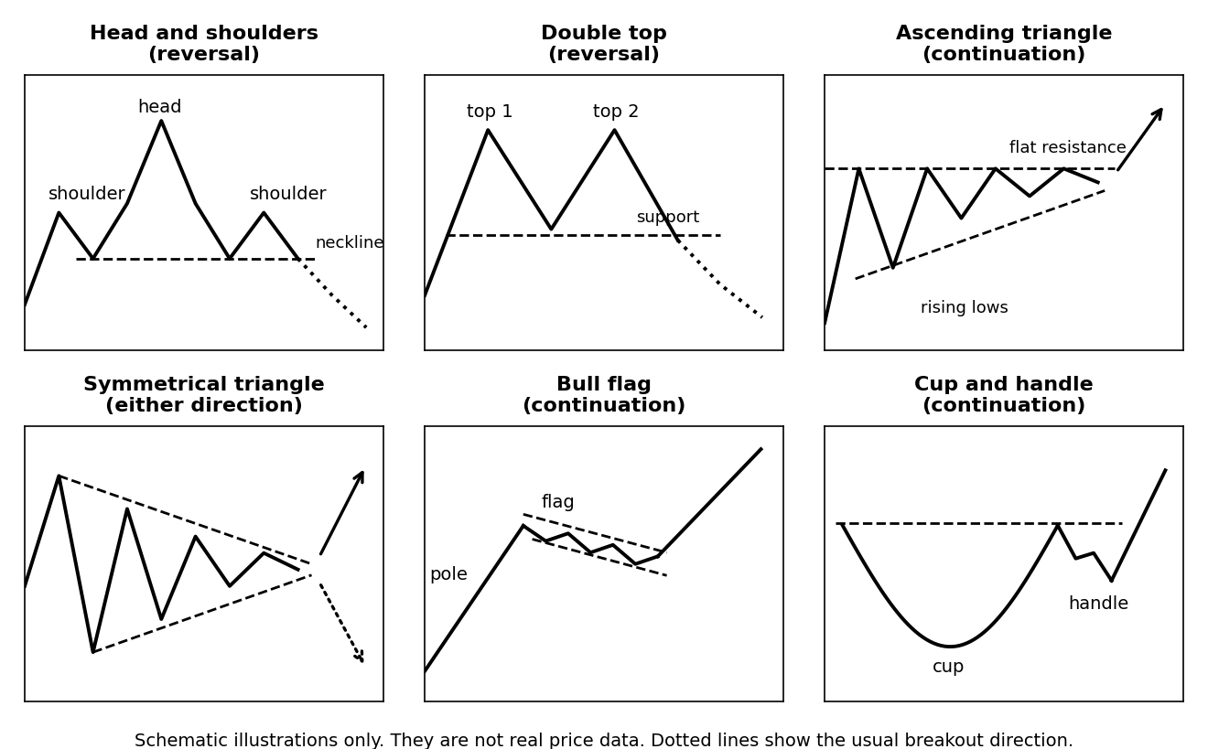
Figure 1. Schematic examples of six common patterns. These are teaching illustrations, not real price data.
How do patterns influence prices? The honest answer is that they do not cause anything. They are a record of supply and demand. A head and shoulders matters because it shows buyers failing to make a new high on the third attempt, and traders who watch the same signal then sell in the same area. Patterns work, when they work, partly because many people react to them together. That is also why I look for confirmation, and why I never act on a pattern that has not broken out.

4. Stock One: Microsoft (MSFT)

4.1 The price story
Microsoft's chart over the last year has two very different halves. The shares set their highs in a $553 to $555 area during 2025. Then they fell about 37% to a 52-week low of $349.20 on 24 June 2026, even though the company's results were strong. A fall like that in a mega-cap is unusual, and Microsoft fell harder than other big technology names did over the same stretch. Coverage at the time pointed to worries about the cost of AI spending and its effect on free cash flow, which matches what I found in Week 2.
From that low the recovery has been sharp. The shares were back near $509 by 30 September, and on 13 October they closed at a record $543.45. On 16 October it fell 1.9% to $529.05. That leaves it 51.5% above the June low and 4.5% below the 52-week high.

4.2 Indicators
Indicator | Reading | What it says
Price versus 50-day simple average ($503.91) | +5.0% above | Medium-term trend is up
Price versus 200-day simple average ($434.78) | +21.7% above | Long-term trend is up, but price is stretched above its base
50-day exponential average / 200-day exponential average | $496.94 / $455.92 | Price is above both
50-day versus 200-day simple average | $503.91 against $434.78 | Golden cross configuration (50-day well above 200-day)
MACD (12, 26) | 12.04, signal line 10.54, histogram +1.5 | Bullish, momentum positive but not accelerating sharply
RSI (14) | 71.2 on one site, 62.4 on another | Upper end of neutral to just overbought
Distance from 52-week high | -4.5% | Very close to resistance
Table 4. Microsoft indicators. Averages and MACD as of 14 October 2026 close.
The two RSI figures are worth a comment. They were both published for the same date, yet one says 71.2 and the other 62.4. The gap probably comes from how each vendor smooths the calculation and which price series it uses. I would rather show both than choose the one that fits a story. Either way, momentum was warm but not extreme, and the 1.9% fall on 16 October will have cooled it a little.

4.3 Patterns I see
- A V-shaped recovery. The stock rose about 51% from $349.20 without building a base first. That is a sharp reversal rather than a classic pattern, and it tells me buyers stepped in hard after the sell-off. Fast recoveries leave little support just beneath the price, which is why the 50-day average matters.
- A defined ceiling at $540 to $555. The 52-week high of $553.72, the old highs near $555 and the record close of $543.45 all sit in this band. Price has now approached it for what looks like the third time. A ceiling that gets tested repeatedly can end in a breakout or a failure. I cannot tell which from the chart alone.
- Not a confirmed triple top. It is tempting to call the repeated highs a triple top, but a double or triple top only counts once price breaks the support between the peaks. Here the trough between the peaks is the $349.20 low, about 34% below the current price. So the pattern is a possibility, not a signal.
- Trend structure. Since June the stock has made higher lows, and it has stayed above a rising 50-day average. That is a healthy uptrend by the usual definition.

4.4 Levels
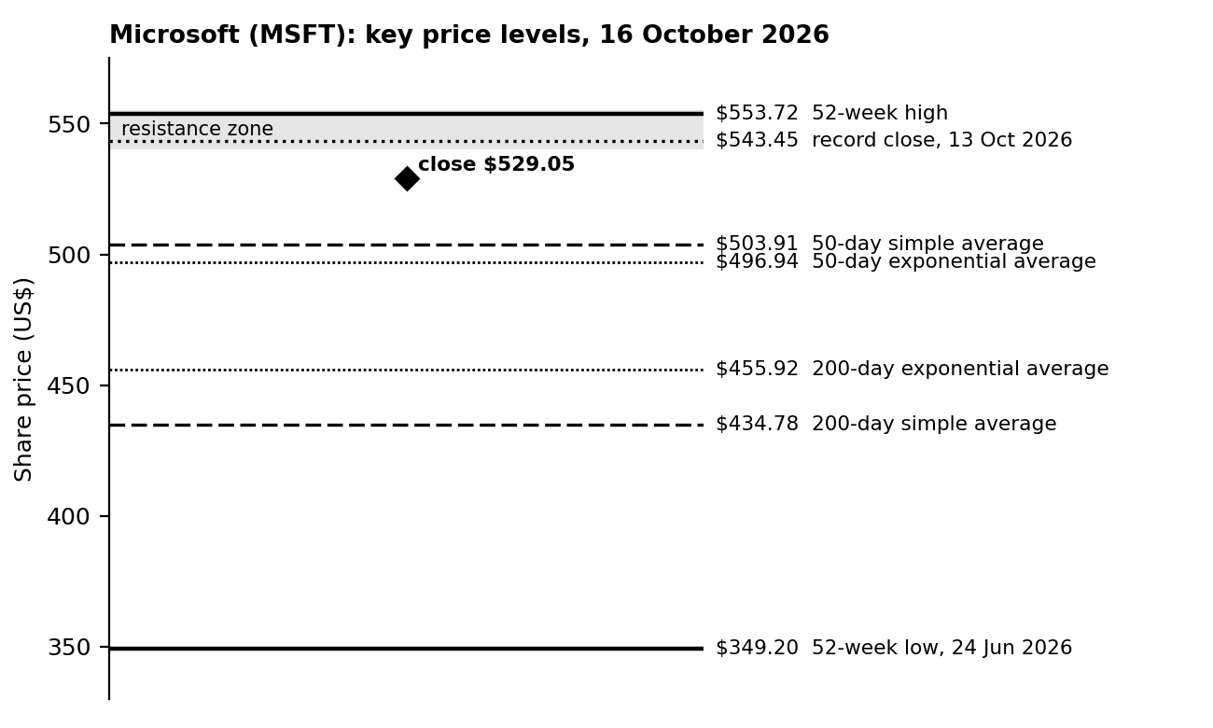
Figure 2. Microsoft key price levels, built from the reported values in Table 4. This is a level map, not a price chart.
Resistance sits at $540 to $555. Support begins at the 50-day average around $504, then near $496 to $497, with the 200-day averages at $434.78 and $455.92 below that. These are the levels I would watch.

4.5 Interpretation
The chart is constructive but late-stage in the short term. The long-term trend is up, the medium-term trend is up and momentum is positive. Against that, the price is close to a ceiling that has stopped it before, it sits more than 20% above its 200-day average, and the next catalyst is large. Microsoft reports on 28 October, and the Federal Reserve announces its decision the same day, with the 10-year Treasury yield near a two-decade high. Events like that can push a stock through a technical level in either direction in a single session.

5. Stock Two: JPMorgan Chase (JPM)

5.1 The price story
JPMorgan has been in an ascending channel since the April 2025 low of $202.16. It reached an all-time high of $366.50 on 13 August 2026, then pulled back about 11.1% to $325.87 on 1 October. That fall stalled almost exactly at two levels chartists watch closely: the 200-day moving average and the 61.8% Fibonacci retracement of the prior advance.
On 13 October the bank reported third-quarter results. Net income rose 6% to $15.3 billion, but diluted earnings per share of $5.57 (or $5.75 excluding a $658 million securities loss) fell short of estimates of roughly $5.9. It was the first miss since the fourth quarter of 2023. Investment banking fees were up 14% from a year earlier but down 8% from the prior quarter. The shares nevertheless held at about $336, helped by a better outlook for net interest income. I also noticed that, going into the report, bank shares generally were lagging: a major bank ETF was about 12% below its mid-August high while the S&P 500 and Nasdaq were at record highs.

5.2 Indicators
Indicator | Reading | What it says
Price versus 200-day simple average ($321.77) | +4.4% above | Long-term trend still intact, but with little cushion
200-day exponential average | $325.15 | Right at the correction low, a key support cluster
50-day simple average (OANDA) | $351.55 | Above price, acting as resistance
50-day exponential average | $345.46 | Above price, short-term trend is down
10-day and 20-day exponential averages (5 Oct) | $337.71 and $342.84 | Both above price at the time, a short-term downtrend
RSI (14) | 59.9 | Neutral to firm, not overbought
MACD (12, 26) | +0.62 | Slightly positive, a tentative improvement
Pivot support zone | $315.70 to $323.00 | Where buyers would be expected to return if the 200-day fails
Table 5. JPMorgan indicators. Averages from a TradingView-based review dated 5 October 2026 and OANDA; RSI and MACD from Investing.com, 9 October 2026.
A note of caution on one source. Another site listed different moving average values for JPMorgan on the same page, and they did not fit with the other two sources or with the price history. I left those out and relied on the two sources that agreed with each other.

5.3 Patterns I see
- A pullback inside an uptrend. The structure is a correction from the August high down to the lower edge of a rising channel and the 200-day average. If the channel holds, this is a normal pause in an uptrend. If it breaks, the channel becomes a ceiling instead.
- A possible bull flag or a deeper correction. The decline from $366.50 to $325.87 followed by a small bounce could be a flag, which would point to another move up. It could equally be the start of a larger correction. Price needs to break one way to tell me.
- A confirmation level. A close above the 50-day average near $351.55 would be the first sign that buyers are back in control. Below it, the short-term averages stay in the way.

5.4 Levels
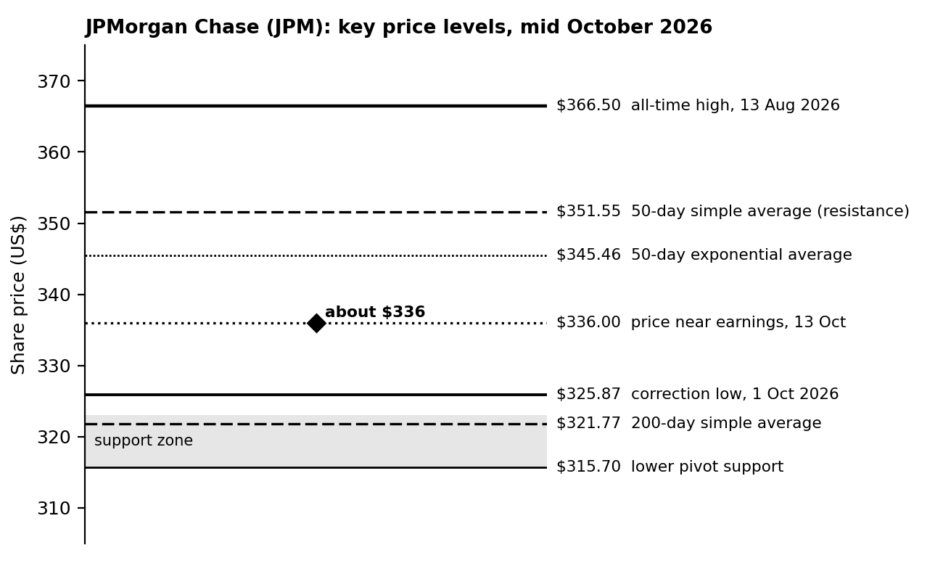
Figure 3. JPMorgan key price levels, built from the reported values in Table 5. This is a level map, not a price chart.

5.5 Interpretation
JPMorgan looks like a strong stock having a pause. The long-term trend is up, and the pullback has landed on the exact area where support would be expected. Momentum is neutral, which is a healthier reading than the overbought look Microsoft has. What it lacks is confirmation. Until price recovers above the 50-day average, the short-term picture is still a correction. The fundamental backdrop is mixed: net interest income looks supportive, while capital markets revenue cooled from an unusually strong first half.

6. Comparing the Two
 | Microsoft (MSFT) | JPMorgan (JPM)
Long-term trend | Up (price 21.7% above 200-day average) | Up (price about 4.4% above 200-day average)
Medium-term trend | Up, 5.0% above 50-day average | Correcting, 50-day average about 4.6% above price
Momentum | Positive MACD, RSI 62 to 71 | Slightly positive MACD, RSI about 60
Nearest resistance | $540 to $555 | $351.55, then $366.50
Nearest support | $504, then $435 | $321.77 to $325.87, then $315.70
Pattern | V-shaped recovery into a tested ceiling | Pullback to channel support and the 200-day average
Main near-term event | Earnings and Fed decision on 28 Oct | Digesting Q3 results; rate path and credit conditions
Technical stance | Constructive, extended near resistance | Neutral and improving, needs confirmation
Table 6. Side-by-side technical comparison.
The contrast is useful. Microsoft has run up into resistance and looks stretched, while JPMorgan has pulled back to support and looks rested. Technical analysis does not say which stock is the better company. It says where each one is in its own cycle.

7. Recommendations and Market Signals
These are technical views to be reviewed as prices move, not instructions to buy or sell. For each stock I list what would make the picture better, what would make it worse, and what I would watch.
 | Bullish signal | Bearish signal | What I would monitor
Microsoft | A daily close above about $555 on heavier-than-usual volume would take it into new high ground and turn the ceiling into support. | A close below the 50-day average near $504, especially on rising volume, would suggest the ceiling has held and open the way toward $455 and $435. | Reaction to the 28 October results and Fed decision; whether RSI falls back below 70 without price breaking down; volume at the $540 to $555 area.
JPMorgan | A close above the 50-day average near $351.55 would show buyers regaining control, with $366.50 as the next test. | A close below the 200-day average near $321 to $325 would break the channel support and point to $315.70 and lower. | Whether the 1 October low of $325.87 holds; bank sector strength against the S&P 500; direction of the 10-year yield.
Table 7. Signals to watch.

7.1 Worked example: risk and reward
A level is only useful if the reward for being right is bigger than the loss if wrong. Using the levels from this report, here are the numbers for possible entries.
Idea | Entry | Stop | Target | Risk per share | Reward per share | Reward to risk
Microsoft, buy at the 50-day average | $505 | $434 (below 200-day) | $555 | $71 (14.1%) | $50 (9.9%) | 0.7 : 1
Microsoft, buy at the 200-day exponential average | $456 | $430 | $555 | $26 (5.7%) | $99 (21.7%) | 3.8 : 1
JPMorgan, buy at support | $322 | $315 | $351.55 | $7 (2.2%) | $29.55 (9.2%) | 4.2 : 1
JPMorgan, same entry to the record high | $322 | $315 | $366.50 | $7 (2.2%) | $44.50 (13.8%) | 6.4 : 1
Table 8a. Risk and reward at selected levels. Levels are from this report; entries are examples.
The result is useful. Buying Microsoft at the 50-day average, with a stop below the 200-day average, risks $71 to make $50, which is not attractive. Waiting for the deeper level changes the same trade to about 3.8 to 1. For JPMorgan the stop at the pivot is close, so the ratio is better. Position size is a separate question. If the most one is willing to lose on a trade is 0.5% of a US$100,000 portfolio, which is $500, the stop distance of $7 would allow 71 shares ($22,900). But a limit of 5% per stock ($5,000) allows only about 15 shares, so in this case the position cap, not the stop, sets the size. In practice the smaller of the two limits applies.
My overall view, in plain terms, is that Microsoft deserves patience and JPMorgan deserves a watching brief. For Microsoft, the chart says the trend is healthy but the price is close to a level that has stopped it before. That agrees with my Week 2 conclusion that the shares look fully valued, so the two kinds of analysis are pointing the same way: wait for either a breakout with volume or a pullback toward the 50-day average rather than chasing. For JPMorgan, the chart is waiting for confirmation. That fits the valuation evidence too, since Morningstar rates the shares as fairly valued, and the stock trades at roughly 14 times the 2026 earnings analysts expect.
On risk control, the approach I would use is simple. Decide in advance where the view is wrong. For a longer-term holder that could be a close below the 200-day average, and for a shorter-term view the 50-day average. Then size the position so that being wrong at that level is a loss one can accept.

8. Limitations
- Indicators lag. Moving averages and MACD describe what has already happened, and a sharp event can change the picture overnight.
- Vendors differ. RSI and moving averages came from different websites and do not always match. I noted where this showed up.
- Patterns are subjective. Two analysts can draw the same chart and see different shapes. I tried to stick to confirmation rules rather than call patterns early.
- Snapshot in time. The readings are from specific dates in October 2026 and will have moved. The JPMorgan price is the latest I could verify, from 13 October.
- No back-testing. I did not test how often these signals worked historically for these stocks, which a more complete study would do.
- Event risk. Earnings, Federal Reserve decisions and geopolitical news can override any technical level.
- Not advice. This is a learning exercise and not a recommendation.

9. Conclusion
Using the same tools on two different stocks gave two different pictures. Microsoft is in a clear uptrend that has run quickly into resistance, with a major event next week. JPMorgan is in a long-term uptrend that is correcting and sitting right on support. In both cases the useful output is not a prediction but a set of levels and conditions: what to watch, what would confirm the trend and what would break it. Combined with the valuation work from Week 2, the overall message for Microsoft is to be patient and for JPMorgan to wait for confirmation.

10. Sources
- Yahoo Finance, Microsoft (MSFT) quote, 16 October 2026: https://finance.yahoo.com/quote/MSFT/
- AlgovestIQ, MSFT technical analysis (14 October 2026 values): https://www.algovestiq.com/stock/msft/technicals
- Financhill, MSFT technical analysis: https://financhill.com/stock-price-chart/msft-technical-analysis
- MarketBeat, "Why Microsoft Looks Like the Best Big Tech Trade for H2 2026": https://www.marketbeat.com/articles/why-microsoft-looks-like-the-best-big-tech-trade-for-h2-2026/
- OANDA, "JPMorgan Q3 Earnings Preview": https://www.oanda.com/sg-en/skills-and-insights/education/trading-asset-classes/shares/jpmorgan-q3-earnings-preview/
- mexc crypto-pulse, "JPMorgan Chase (JPM) Technical Analysis: Key Support and Resistance Levels Ahead of Q3 Earnings" (TradingView data, 5 October 2026): https://www.mexc.com/crypto-pulse/article/jpmorgan-chase-jpm-technical-analysis-165874
- Investing.com, JPM technical analysis: https://www.investing.com/equities/jp-morgan-chase-technical
- AskTraders, "JPMorgan Shares Gain Despite Surprise Profit Miss": https://www.asktraders.com/?p=256179
- Beinsure, "JPMorgan Chase stock forecast: earnings miss, 2027 outlook": https://beinsure.com/news/jpmorgan-chase-stock-forecast-earnings-miss/
- Morningstar, "JPMorgan Earnings: Solid Results Despite Capital Markets Softening": https://www.morningstar.com/stocks/jpmorgan-earnings-solid-results-despite-capital-markets-softening
- stock3, "JPMorgan-Aktie im Blick" (citing CNBC on bank ETF performance): https://stock3.com/news/jpmorgan-aktie-im-blick-analysten-erwarten-17-prozent-mehr-gewinn-pro-aktie-17327037
- CNBC, "10-year Treasury yield climbs back to 5% after Fed hikes rates", 16 September 2026: https://www.cnbc.com/2026/09/16/treasury-yield-bond-market-fed-decision.html

Week 4 Report: Risk Assessment and Portfolio Diversification Strategy
Focus: market risk factors, a hypothetical US$100,000 portfolio, and a diversification plan
Prepared by: Nayana Sheelavant Date: 19th October, 2026

1. Introduction
The first three weeks were about finding and judging opportunities. This week is about the other side: what can go wrong, how badly, and what a sensible investor does about it. I think this is the part most beginners skip, so I wanted to do it carefully.
I started by collecting evidence on the risks present in markets right now, then built a hypothetical portfolio of US$100,000 that looks like what an enthusiastic technology investor might hold after the last few years. I measured its risk in several ways, ran it through four stress scenarios and a simulation of 200,000 possible years, and then designed a more diversified alternative and compared the two. None of this is real money and none of it is investment advice.

2. The Market Risk Environment, With Evidence
Before looking at a portfolio, I wanted to know what the market itself is saying. The table collects the main readings I could verify. Several of them point to a more difficult backdrop than the record highs in stock indices might suggest.
Indicator | Latest reading | Source | Why it matters
Federal Reserve policy rate | 3.75% to 4.00% after a 25 basis point hike on 16 Sep 2026, the first rise since 2023, by unanimous vote | Federal Reserve; Schwab | Higher borrowing costs weigh on company profits and on stock valuations
Fed projections | Median forecast has the rate at 4.1% by year-end, so one more hike is expected | J.P. Morgan Asset Management | Tightening may not be over
10-year Treasury yield | About 5.0%, near a 19-year high and up roughly 80 basis points this year | CNBC; Schwab | A risk-free 5% competes with stocks and raises the discount rate on future earnings
Inflation | Roughly 3.7% year on year, above the 2% target | Trading Economics | Keeps the Fed cautious and erodes real bond returns
Oil | Brent crude near $104 a barrel on 18 Sep 2026 | Xinhua | An energy shock can feed inflation and slow growth
US stocks | S&P 500 near 7,650 on 18 Sep, up more than 11% for the year as of 14 Sep, with the S&P 500 and Nasdaq at record highs in early October | Xinhua; CNBC (via stock3) | High prices leave less margin for error
Bank stocks | A major bank ETF about 12% below its mid-August high even as indices hit records | CNBC (via stock3) | Shows how unevenly the market is moving
A single-stock example | Microsoft fell about 37% from its 2025 high to a June 2026 low, then rebounded about 51% | MarketBeat; Yahoo Finance | Even an excellent company can have a severe drawdown
Scheduled events | Fed decision and Microsoft earnings on 28 Oct; US midterm elections in early November | Fed calendar; company | Event risk is concentrated in the next few weeks
Table 1. Market risk indicators.
The most important line for me is the combination of a 5% risk-free yield and record-high stock prices. When safe assets pay more, the extra return from taking equity risk looks smaller, and the stock market has less cushion if something goes wrong.

3. Risk Factors Identified
Risk | What it means | Evidence now | Effect on a technology-heavy portfolio
Equity market risk | The whole market falls | Indices at record highs; high valuations | Large, since the portfolio is mostly equities
Interest rate risk | Rising yields lower the value of long-dated cash flows and bonds | Fed hike in September; 10-year near 5% | Technology stocks are long-duration assets. Bond prices also fall when yields rise.
Inflation risk | Prices rise faster than expected | Inflation about 3.7%; oil above $100 | Pushes rates higher and can make stocks and bonds fall together, as in 2022
Concentration and valuation risk | Too much money in one theme or stock | AI spending dominates the sector; Microsoft traded at about 30 times earnings | The biggest risk in my hypothetical Portfolio A
Single-company risk | A company-specific shock | Microsoft fell 37% in 2026 despite strong results | A single holding can undo a lot of gains
Geopolitical and energy risk | Conflict, trade or supply shocks | Oil price; chip export controls and tariffs | Hits both costs and demand, and chip supply chains in particular
Event risk | Big news arrives at a fixed date | Fed and Microsoft earnings on 28 Oct; elections | Price gaps can happen overnight
Liquidity and behavioural risk | Being forced, or tempted, to sell at the worst time | Not visible in data, but real in every sell-off | A portfolio that falls 35% is much harder to hold than one that falls 15%
Table 2. Risk factors and how they apply.

4. The Hypothetical Portfolios
I defined two portfolios of US$100,000 each. Portfolio A is a concentrated technology portfolio, the sort someone might end up with after riding the AI trade. Portfolio B is the diversified version I would propose instead. I used index-style building blocks so that the analysis is about asset allocation and not about picking individual stocks.
Asset class | Proxy index | Portfolio A | Portfolio B
US technology | Nasdaq-100 | 70% ($70,000) | 15% ($15,000)
US broad equity | S&P 500 | 20% ($20,000) | 30% ($30,000)
International developed equity | MSCI EAFE | 0% ($0) | 15% ($15,000)
US investment-grade bonds | Bloomberg US Aggregate Bond | 0% ($0) | 25% ($25,000)
Gold | Spot gold | 0% ($0) | 10% ($10,000)
Cash | 3-month Treasury bills | 10% ($10,000) | 5% ($5,000)
Table 3. Portfolio compositions.

4.1 Planning assumptions
To measure risk I need an expected return, a volatility (the usual size of annual swings) and a correlation for each asset class. I did not take these from a forecast. They are round planning figures based on long-run historical ranges, adjusted loosely for today's yields, and they are my assumptions. Changing them will change the results, which is a limitation I come back to.
Asset class | Expected return | Volatility
US technology | 8.0% | 22.0%
US broad equity | 7.0% | 16.0%
International developed equity | 6.5% | 17.0%
US investment-grade bonds | 5.0% | 6.0%
Gold | 3.5% | 15.0%
Cash | 4.0% | 0.5%
Table 4. Expected return and volatility assumptions (annual).
 | Tech | Broad | Intl | Bonds | Gold | Cash
Tech | 1.00 | 0.90 | 0.75 | 0.25 | 0.00 | 0.00
Broad | 0.90 | 1.00 | 0.85 | 0.25 | 0.05 | 0.00
Intl | 0.75 | 0.85 | 1.00 | 0.20 | 0.15 | 0.00
Bonds | 0.25 | 0.25 | 0.20 | 1.00 | 0.30 | 0.00
Gold | 0.00 | 0.05 | 0.15 | 0.30 | 1.00 | 0.00
Cash | 0.00 | 0.00 | 0.00 | 0.00 | 0.00 | 1.00
Table 5. Correlation assumptions. Stock and bond correlation is set positive at 0.25 because stocks and bonds fell together in 2022.

5. Measuring the Risk

5.1 What I measured
- Volatility. The annual standard deviation of returns for the whole portfolio, calculated from the weights, volatilities and correlations.
- Beta. How much the portfolio moves for a 1% move in the S&P 500.
- Value at Risk (VaR), 95%, one year. The loss that should only be exceeded in about 1 year out of 20. I used the normal-distribution formula: VaR = -(expected return - 1.645 x volatility).
- Conditional VaR (CVaR). The average loss in the worst 5% of years. It tells you how bad the bad years are, not just where they start.
- Sharpe ratio. Return above cash divided by volatility, using 4% as the cash return.
- Risk contribution. Each asset's share of the portfolio's total variance. It shows where the risk really comes from, which can differ a lot from where the money is.

5.2 Results
Measure | Portfolio A (concentrated) | Portfolio B (diversified)
Expected annual return | 7.4% | 6.1%
Volatility | 18.3% | 10.8%
Beta against the S&P 500 | 1.07 | 0.65
VaR, 95%, one year | 22.8% ($22,758) | 11.8% ($11,771)
CVaR (average loss in worst 5% of years) | 30.4% ($30,407) | 16.3% ($16,298)
Sharpe ratio | 0.19 | 0.19
Diversification ratio | 1.02 | 1.26
Share of risk from US technology | 83.8% | 27.8%
Table 6. Risk metrics. The diversification ratio is the weighted average of individual volatilities divided by the portfolio volatility; a figure near 1 means almost no diversification benefit.
The headline is how much the risk fell and how little the expected return did. Moving from A to B cut volatility by 41% (from 18.3% to 10.8%), cut the one-year VaR by 48% and cut the average loss in the worst years by 46%. The price was 1.3 percentage points of expected return. Beta fell from 1.07 to 0.65.
The Sharpe ratio barely moved (0.19 against 0.19). That means diversification did not make the portfolio worse per unit of risk. It simply let it take far less risk. Under my assumptions, technology compensates you only slightly better than the broad market for its extra volatility, so concentrating in it does not pay for itself.
Portfolio A is the clearest example of why risk contribution matters. Technology is 70% of the money but about 84% of the risk. The diversification ratio of 1.02 is close to 1, which tells me the portfolio is almost a single bet. In Portfolio B no sleeve contributes more than about 42% of the risk, and bonds and gold, which are 35% of the money, add only about 9% of the risk, which is exactly their job.
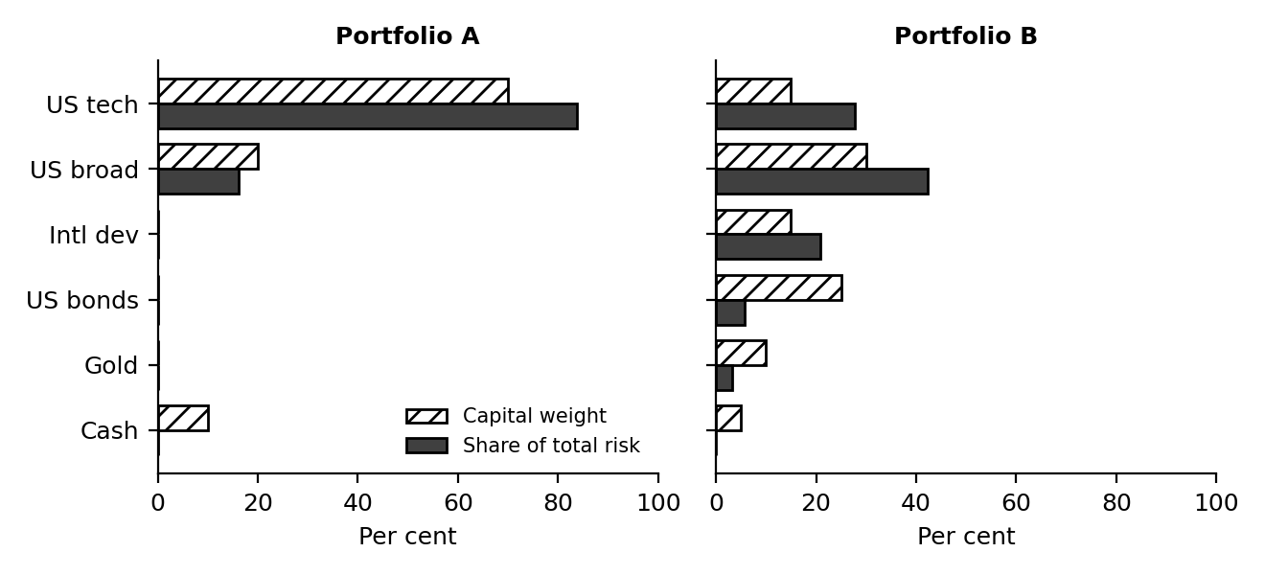
Figure 1. Share of capital compared with share of total risk, by asset class.

5.3 Worked examples
To show where the numbers in Table 6 come from, here are the calculations for Portfolio A and Portfolio B written out.
Calculation | Working | Result
Expected return, Portfolio A | 70% x 8.0% + 20% x 7.0% + 10% x 4.0% | 5.60 + 1.40 + 0.40 = 7.40%
Expected return, Portfolio B | 15% x 8.0% + 30% x 7.0% + 15% x 6.5% + 25% x 5.0% + 10% x 3.5% + 5% x 4.0% | 1.20 + 2.10 + 0.98 + 1.25 + 0.35 + 0.20 = 6.08%
Variance of A (technology and broad equity; cash adds almost nothing) | 0.70^2 x 0.22^2 + 0.20^2 x 0.16^2 + 2 x 0.70 x 0.20 x 0.90 x 0.22 x 0.16 | 0.023716 + 0.001024 + 0.008870 = 0.033610
Volatility of A | Square root of 0.033610 | 18.33%
One-year VaR at 95%, A | -(7.40% - 1.645 x 18.33%) | 22.75%, or $22,750 on $100,000
Loss in the 2008 scenario, A | 70% x (-42%) + 20% x (-37%) + 10% x (+2%) | -29.40 - 7.40 + 0.20 = -36.6%
Loss in the 2008 scenario, B | 15% x (-42) + 30% x (-37) + 15% x (-43) + 25% x 5 + 10% x 5 + 5% x 2 | -6.30 - 11.10 - 6.45 + 1.25 + 0.50 + 0.10 = -22.0%
Table 6a. Risk calculations written out.
The correlation of 0.90 between technology and broad equity is the reason the cross term (0.008870) is so large. If the two were uncorrelated, the cross term would be zero and the volatility of A would fall to about 15.7%. Because they are highly correlated, mixing them barely reduces risk, which is the central point of the week.

5.4 Worked example: rebalancing
Step | Portfolio B in dollars | Weight of technology
Start | Technology $15,000; everything else $85,000; total $100,000 | 15.0%
Technology rises 40%, others flat | Technology $21,000; total $106,000 | 19.8%, drift of 4.8 points (below the 5-point trigger, no action)
Technology rises 45%, others flat | Technology $21,750; total $106,750 | 20.4%, drift of 5.4 points (trigger reached)
Rebalance | Target 15% x $106,750 = $16,013. Sell $21,750 - $16,013 = $5,737 of technology and spread it across the other asset classes in proportion to their targets | Back to 15.0%
Table 6b. How the 5-point rebalancing rule works.

6. Scenario Analysis

6.1 Stress tests
Metrics based on assumed volatilities say little about what happens in a real crisis, when correlations jump and assets that normally offset each other fall together. So I applied each portfolio to three past episodes and one hypothetical scenario. The table shows what each asset class did in each scenario, and the resulting loss for the portfolio.
Scenario | Tech | Broad | Intl | Bonds | Gold | Cash | A | B
Dot-com bust, 2000 to 2002 (cumulative) | -73% | -38% | -43% | +34% | +19% | +12% | -57.5% | -17.8%
Global financial crisis, 2008 | -42% | -37% | -43% | +5% | +5% | +2% | -36.6% | -22.0%
Inflation and rate shock, 2022 | -33% | -18% | -15% | -13% | 0% | +2% | -26.5% | -15.8%
Hypothetical: AI spending unwind plus higher yields | -40% | -22% | -15% | -6% | +5% | +2% | -32.2% | -15.8%
Table 7. Asset class returns in each scenario and resulting portfolio outcome. Historical figures are approximate, rounded, and based on index total returns for the proxies in Table 3.
A word on the numbers. The three historical rows are rounded calendar-year or cumulative figures that I compiled from index provider data, and they should be read as close approximations. Anyone using them seriously should check them against the index providers' fact sheets. The fourth scenario is my own. It imagines that spending on AI disappoints and yields rise further, with technology down 40%, the broad market down 22%, bonds down 6% and gold up 5%. It is a thought experiment built from the risks in Section 2, not a forecast.
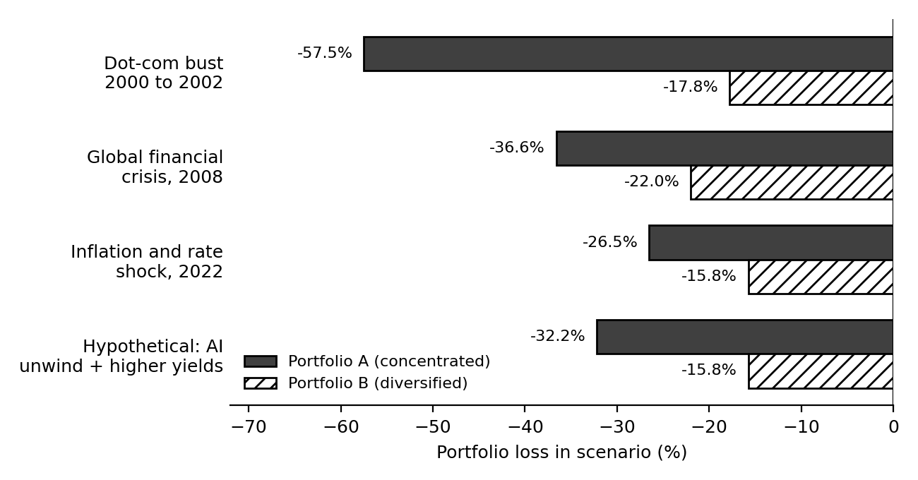
Figure 2. Portfolio loss in each stress scenario. Portfolio B loses roughly a third to a half as much as Portfolio A in every case.
Portfolio A would have lost about 57% in the dot-com bust and 37% in 2008. Portfolio B would have lost about 18% and 22%. The inflation episode of 2022 is the instructive one. It is the only scenario in which bonds fell alongside stocks, and it looks the most like today. Even there, Portfolio B lost 16% against 27% for A, but a 16% loss is still painful. Bonds are not a perfect hedge when inflation is the cause of the sell-off. I address that in the recommendations.

6.2 Monte Carlo simulation
The stress tests show only four paths. To see a wider range I simulated 200,000 possible one-year outcomes for each portfolio. The simulation draws returns from the assumptions in Tables 4 and 5, but it uses a Student-t distribution with 5 degrees of freedom instead of a normal curve, so that extreme years happen more often than a bell curve allows. I set the random seed to 2026 so that the numbers can be reproduced.
One-year result | Portfolio A | Portfolio B
Average return | 7.4% | 6.1%
Return in the 5th percentile (1 year in 20 is worse) | -21.2% | -10.8%
Return in the 1st percentile (1 year in 100 is worse) | -40.0% | -22.1%
Average of the worst 5% of years | -33.4% | -18.1%
Probability of any loss | 31.1% | 25.0%
Probability of losing more than 10% | 13.7% | 5.7%
Probability of losing more than 20% | 5.6% | 1.3%
Table 8. Monte Carlo results, 200,000 simulated years each.
In the simulation, Portfolio A loses more than 10% in about 14 years out of 100, and more than 20% in about 6. Portfolio B loses more than 10% in about 6 years out of 100 and more than 20% in about 1. The probability of simply losing money in a year only falls from about 31% to 25%, which is a useful reminder that diversification does not remove losing years. It shrinks the size of the losses. The one-year VaR from the simulation (21.2% for A and 10.8% for B) is close to the formula-based numbers in Table 6, which gives me some confidence that the two methods are consistent.

7. Diversification Strategy and Recommendations

7.1 Target allocation
Asset class | A | B | Change | Change ($) | Role in the portfolio
US technology | 70% | 15% | -55 pts | -$55,000 | Keeps exposure to the AI and software themes I researched in Weeks 1 to 3 but stops it dominating. Note that the S&P 500 holds a large technology weight too, so the real technology exposure in B is higher than 15%.
US broad equity | 20% | 30% | +10 pts | +$10,000 | The core equity holding. Wide spread across companies and sectors.
International developed equity | 0% | 15% | +15 pts | +$15,000 | Adds exposure to other economies, currencies and sector mixes. It is still equity risk, so it helps less in a global sell-off than other assets do.
US investment-grade bonds | 0% | 25% | +25 pts | +$25,000 | Gives income at current yields and a cushion in growth-driven sell-offs (it worked in 2000 to 2002 and 2008). It did not help in 2022.
Gold | 0% | 10% | +10 pts | +$10,000 | Held for crisis and inflation protection. It rose or held up in all but one scenario here, and had little connection to technology in my assumptions. It pays no income.
Cash | 10% | 5% | -5 pts | -$5,000 | Provides stability, liquidity for rebalancing, and a return of about 4% at current policy rates.
Table 9. From Portfolio A to Portfolio B.

7.2 How I would get there
- Move in stages. Selling $55,000 of technology in a single day is a timing decision in itself. I would shift in three to six tranches so that no single day decides the result. If selling triggers tax, that cost should be weighed first.
- Use index funds for the technology sleeve. This keeps single-company risk, the Microsoft-type drawdown, out of the portfolio.
- Cap individual stocks. No single stock above about 5% of the portfolio.
- Split the bond sleeve. Hold a mix of short-to-intermediate Treasuries and inflation-linked bonds, so that a repeat of 2022 hurts less. Avoid very long maturities while yields are still rising.
- Rebalance by rule. Check at least once a year, and also whenever any asset class drifts more than 5 percentage points from its target. This forces selling what has run up and buying what has lagged, without relying on opinion.
- Keep an emergency fund outside the portfolio. Three to six months of expenses, so that a bad market never forces selling.
- Avoid leverage. Borrowing to invest turns a bad year into a forced sale.
- Optional hedging. For anyone who must hold a large single stock, a protective put or a collar can limit losses, at a cost. I would treat it as an exception, not the standard.

7.3 What I would monitor
These are my own review triggers, chosen to prompt a rethink. They are not market signals or forecasts.
Indicator | Reading now | Review trigger | What I would do
10-year Treasury yield | About 5.0% | Sustained move above about 5.25% | Review bond maturities and technology weight
Fed policy path | 3.75% to 4.00%, one more hike expected | More hikes than the Fed has signalled | Reassess equity risk and bond duration
Inflation | About 3.7% | Above about 4%, or oil sustained above $110 | Increase inflation-linked bonds and gold within limits
Technology earnings | Microsoft reports 28 Oct | Higher spending with weaker cloud growth | Revisit the technology sleeve
Portfolio drawdown | Not applicable | Down 10% from the peak | Review against plan, rebalance by rule, avoid panic selling
Table 10. Monitoring plan.
To summarise what the plan buys. For a loss of roughly 1.3 percentage points of expected return a year, Portfolio B cuts volatility by about 41%, cuts the one-year VaR by about 48% and cuts the loss in the stress scenarios to roughly a third to a half of Portfolio A's. Whether that trade is worth it depends on the investor. For anyone who could not stomach a loss of a third of their money, I think it clearly is.

8. Limitations
- Assumptions drive the numbers. Expected returns, volatilities and correlations are planning figures I chose, not forecasts. Different reasonable inputs would give different results.
- The past is not a promise. The historical scenarios are rounded and approximate, and the next crisis will not match any of them exactly.
- Correlations change. Assets that diversify each other in calm periods can fall together in a panic, as stocks and bonds did in 2022.
- Simplified distributions. The VaR formula assumes a bell curve. The simulation allows fatter tails, but neither captures volatility clustering, where bad days bunch together.
- Proxies, not products. Real funds carry fees, tracking error and tax effects that I have left out.
- Hypothetical portfolio. It is not tailored to anyone's real goals, time horizon or tax position.
- Not advice. This is a learning exercise and not a recommendation to buy or sell anything.

9. Conclusion
The main thing I learned this week is that risk is not where the money is, it is where the correlation is. A portfolio that looks varied because it owns many technology names is really one bet, and my hypothetical Portfolio A shows it: 70% of the money but about 84% of the risk. Moving to a mix of broad equity, international shares, bonds, gold and a little cash cut the risk by roughly 40% to 50% on every measure and cost about 1.3 points of expected return, with the stress tests and the simulation telling the same story.
The market evidence in Section 2 explains why this matters right now. The Fed has started raising rates again, the 10-year yield is near 5%, inflation is above target and stock indices are at record highs. None of that means a crash is coming. It does mean that the cushion for error is thinner than it was a year ago, and that is exactly when a diversified plan with clear rules is worth having.

10. Sources
- Federal Reserve, FOMC statement, 16 September 2026: https://www.federalreserve.gov/monetarypolicy/files/monetary20260916a1.pdf
- CNBC, "10-year Treasury yield climbs back to 5% after Fed hikes rates, Warsh highlights inflation risks", 16 September 2026: https://www.cnbc.com/2026/09/16/treasury-yield-bond-market-fed-decision.html
- CNBC, "10-year Treasury yield hits 5% before reversing as traders await Fed meeting", 14 September 2026: https://www.cnbc.com/2026/09/14/10-year-us-treasury-is-closing-in-on-5percent.html
- Charles Schwab, "Fed Hikes: What's Next for Treasury Yields?": https://www.schwab.com/learn/story/fed-hikes-whats-next-treasury-yields
- J.P. Morgan Asset Management, "FOMC Statement: September 2026": https://am.jpmorgan.com/us/en/asset-management/adv/insights/portfolio-insights/fixed-income/fixed-income-perspectives/fomc-statement-september-2026/
- Trading Economics, United States interest rate and inflation: https://tradingeconomics.com/united-states/interest-rate
- Xinhua via The Star, "U.S. stocks close mixed as Treasury yields rise again", 19 September 2026: https://www.thestar.com.my/news/world/2026/09/19/us-stocks-close-mixed-as-treasury-yields-rise-again
- stock3, "JPMorgan-Aktie im Blick" (citing CNBC on bank ETF performance and index records): https://stock3.com/news/jpmorgan-aktie-im-blick-analysten-erwarten-17-prozent-mehr-gewinn-pro-aktie-17327037
- MarketBeat, "Why Microsoft Looks Like the Best Big Tech Trade for H2 2026": https://www.marketbeat.com/articles/why-microsoft-looks-like-the-best-big-tech-trade-for-h2-2026/
- Yahoo Finance, Microsoft (MSFT) quote: https://finance.yahoo.com/quote/MSFT/
- Index provider fact sheets (S&P Dow Jones Indices, Nasdaq, MSCI, Bloomberg) for historical returns used in the stress tests, rounded: https://www.spglobal.com/spdji

Week 5 Report: Analysis of Economic Indicators and Market Trends
Indicators studied: economic growth (GDP), employment, inflation and interest rates
Prepared by: Nayana Sheelavant Date: 19th October, 2026

1. Executive Summary
This report looks at four economic indicators that matter most to stock markets, what each is saying right now, and how they have related to stock returns in the past. I then use them to build a view of the next six to twelve months.
The picture today is unusual. Stocks are at record highs: the S&P 500 closed at 7,811.54 on 9 October 2026, up 14.1% for the year. Yet the economic data underneath is mixed and, in places, uncomfortable. Growth is steady (US GDP rose 2.2% annualised in the second quarter). Hiring has nearly stalled (only 29,000 jobs were added in September). Inflation is re-accelerating (3.7% in September, driven by a 34% annual jump in gasoline). And the Federal Reserve has started raising interest rates again, which has pushed the 10-year Treasury yield to about 5.2%, a level last seen more than two decades ago.
When I tested how these indicators have lined up with stock returns over 2018 to 2024, the clearest link was with interest rates (a correlation of -0.80 between yearly changes in the Fed funds rate and S&P 500 returns). Growth, inflation and unemployment showed almost no link in annual data, which is itself a lesson: markets look ahead, so they often move before the data does. That result rests on only seven years and is driven largely by 2022, so I treat it as an illustration and not as proof.
My base case is for choppy, range-bound markets with wide gaps between winners and losers, because strong earnings are fighting against the highest yields in years. The main risks to that view are an energy price spike and an inflation surprise on one side, and a sudden labour market crack on the other. Section 8 sets out the scenarios and what would tell me which one is unfolding.
Indicator | Latest reading | Direction | Pressure on stocks
Economic growth | US GDP +2.2% annualised in Q2 2026; IMF sees 2.3% for 2026 | Steady | Supportive
Employment | +29,000 jobs and 4.2% unemployment in September 2026 | Cooling | Mixed
Inflation | CPI 3.7% year on year in September 2026; core 2.6% | Rising | Negative
Interest rates | Fed funds 3.75% to 4.00%; 10-year Treasury about 5.2% | Rising | Negative
Table 1. Summary of the four indicators.

2. Choosing the Indicators and the Sources
The task asks for at least four indicators from globally recognised sources. I picked the four that appear in almost every discussion of what moves markets. Together they cover the economy's output (GDP), the labour market (employment), prices (inflation) and the cost of money (interest rates).
Indicator | Measure used | Source | Latest release used
Economic growth | Real GDP growth, annualised, by quarter; global forecasts | US Bureau of Economic Analysis (BEA); International Monetary Fund (IMF) World Economic Outlook | BEA third estimate, 30 Sep 2026; IMF outlook, 13 Oct 2026
Employment | Nonfarm payrolls and the unemployment rate | US Bureau of Labor Statistics (BLS) | Employment Situation, 2 Oct 2026
Inflation | Consumer Price Index, headline and core | US Bureau of Labor Statistics (BLS) | CPI for September, 14 Oct 2026
Interest rates | Fed funds target range and the 10-year Treasury yield | Federal Reserve; Treasury market data reported by CNBC, AP and others | FOMC statement, 16 Sep 2026; yields to 9 Oct 2026
Table 2. Indicators and data sources.
A note on the market data. Index levels come from Associated Press close-of-day reports. Where I quote yield readings from news sources instead of the Treasury itself, I give the date, because yields moved by several tenths of a percentage point in the past month.

3. Economic Growth

3.1 What the data says
US real GDP grew at an annualised 2.2% in the second quarter of 2026, according to the third estimate published on 30 September. That was revised up sharply from 1.5% in the earlier estimates, mostly because investment, consumer spending and government spending came in stronger than first thought. The first quarter was revised to 2.5%. Gross domestic income, an alternative measure built from incomes, grew 2.6%.
The longer run is bumpy. Growth was negative in the first quarter of 2025 (-0.5%), jumped to 3.8% and 4.4% in the middle of 2025, then dropped to 0.5% at the end of the year before settling near 2.2% to 2.5% in 2026. Quarterly figures swing a lot and get revised, so the trend over several quarters is more useful than any single number.
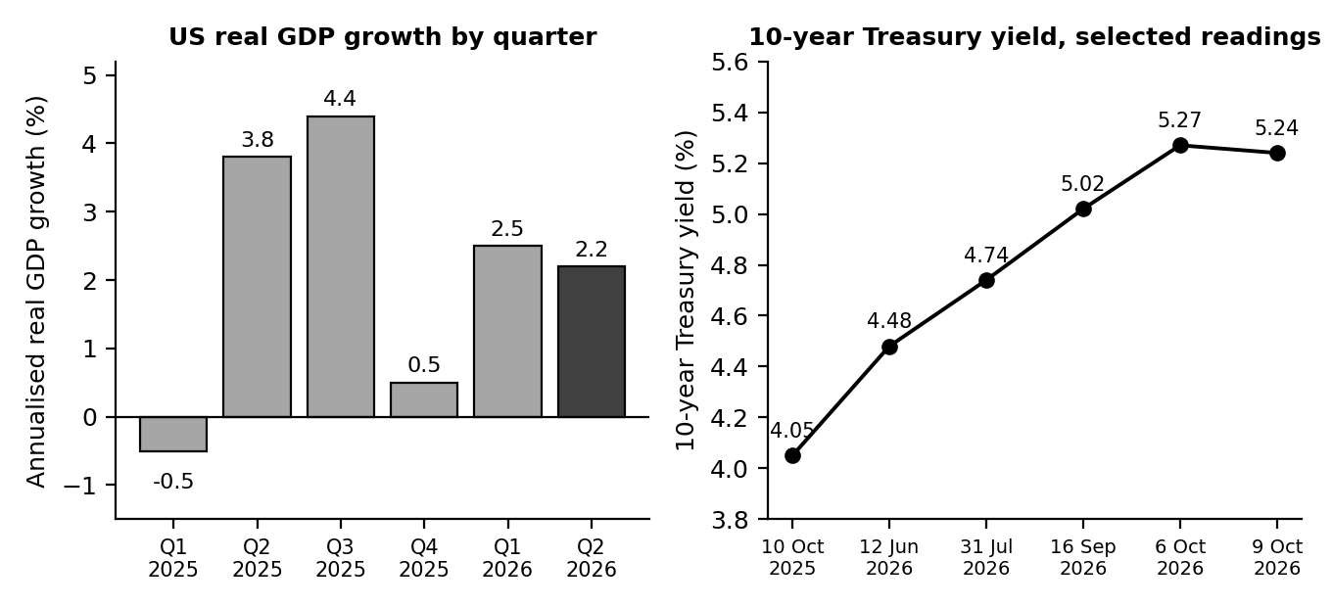
Figure 1. US real GDP growth by quarter (BEA, latest estimates) and selected readings of the 10-year Treasury yield, October 2025 to October 2026.
The 10-year yield readings on the right panel are individual dates I could verify, so the line shows direction rather than a daily history. The direction is clear: from about 4.05% a year ago to about 5.24% on 9 October 2026.

3.2 The global picture
The IMF's October 2026 World Economic Outlook expects world growth to slow from 3.5% in 2025 to 3.1% in 2026, then recover to 3.4% in 2027. For the United States it projects 2.3% growth in both 2026 and 2027, supported by consumer spending, fiscal policy and heavy investment in artificial intelligence. The IMF also flags two things I found important. Growth has become very concentrated, with 32 countries producing about 95% of it, and energy-importing and lower-income economies are struggling with higher fuel and food costs after the Middle East conflict.

3.3 How growth affects markets
Growth drives company revenue and profit, so faster growth normally supports share prices. The relationship is not simple, though. Markets price the future, so what matters is growth compared with expectations, and growth that is too strong can hurt if it makes the central bank raise rates. In 2026 this tension is visible: solid growth is part of the reason the Fed was willing to hike.

4. Employment

4.1 What the data says
The September jobs report, released on 2 October, was weak. Nonfarm payrolls rose by only 29,000 against forecasts of around 85,000 to 90,000, and July and August were revised down by a combined 60,000. The three-month average is now only about 51,000 jobs a month, and for all of 2025 payrolls averaged just 15,000 a month. The unemployment rate rose to 4.2% from 4.1%, though the labour force also grew, with participation at 61.8%. Wage growth was about 3% over the year, now below inflation.
Not everything was soft. The broader unemployment measure, which includes discouraged and part-time workers, fell to 7.6%, its lowest since early 2025. So the labour market is cooling and not breaking. Hiring is slow, but layoffs are not surging.

4.2 How employment affects markets
Jobs matter in two ways. Strong employment supports consumer spending, which is most of the US economy, so a weak labour market is a warning for profits. But because the Fed watches jobs closely, weak data can also lower expectations of rate rises and lift stocks in the short term. The market reaction to the September report showed this. The weak number cut the market-implied odds of an October Fed hike from roughly 70% to about 14% within the week. Bad news was briefly treated as good news.

5. Inflation

5.1 What the data says
The BLS reported on 14 October that consumer prices rose 0.6% in September and 3.7% over the year, up from 3.4% in August and 3.0% a year earlier, and above the 3.6% economists expected. Core inflation, which strips out food and energy, was 2.6% over the year and 0.3% for the month. The headline jump came mostly from gasoline, which rose 9.1% in a single month and 34.2% over the year, with fuel oil up 74% and airline fares up 22%.
One economist pointed out that core inflation ran at a 3.7% annualised pace in September, so the underlying trend is not as calm as the 2.6% annual figure implies. Shelter rose 0.4% in the month. The IMF expects US inflation of 3.6% for 2026, easing to 2.8% in 2027, and global inflation of 4.7% in 2026.

5.2 How inflation affects markets
Inflation hurts stocks mainly through the central bank. Higher inflation leads to higher interest rates, which reduce the present value of future profits. It also squeezes company margins and household budgets. A moderate level of inflation can be absorbed, since companies with pricing power pass costs on. The danger is a surprise, and the September number was a surprise on the upside, with markets now pricing a rate rise before the end of the year at better than 96% odds.

6. Interest Rates

6.1 What the data says
The Federal Reserve raised its target range for the federal funds rate by 0.25 percentage points to 3.75% to 4.00% on 16 September 2026. It was the first increase since July 2023 and the vote was unanimous. The median projection has the rate at 4.1% by the end of 2026, which implies one more hike, with no change in 2027 and cuts only in 2028 and 2029. After the September CPI report, markets moved to price a further increase before year-end with high probability. The next meeting is on 27 and 28 October.
Long-term yields have risen even more than the policy rate. The 10-year Treasury yield was around 4.05% in October 2025 and had reached about 5.24% by 9 October 2026, after touching roughly 5.27% earlier that week, which is about the highest level in more than two decades. With inflation at 3.7%, the 10-year yield sits only about 1.5 percentage points above current inflation, so the so-called real yield is positive and meaningful again.

6.2 How interest rates affect markets
Rates are the most direct link between the economy and stock prices. A higher rate lowers the value of all future profits, and growth companies, whose profits lie further in the future, are hit hardest. Higher yields also give investors a competing safe return: a risk-free 5% looks attractive next to an S&P 500 earnings yield that is much lower. For banks, higher rates can help, since they earn more on loans and deposits, but they also raise the risk of borrowers failing to repay.

7. Relating the Indicators to Stock Returns

7.1 Historical episodes
Before looking at statistics, it helps to see the pattern in a few well-known episodes. The figures below are rounded from standard sources.
Episode | What the indicators did | What stocks did | Lesson
2000 to 2002 | The Fed raised rates to 6.5% in 2000. Growth slowed and a recession followed in 2001. | The Nasdaq fell about 78% from its March 2000 peak. The S&P 500 lost about 38% over 2000 to 2002. | High valuations plus rising rates are a dangerous mix.
2008 | GDP contracted, unemployment rose from about 5% to 10% by late 2009. | The S&P 500 fell 37% in 2008 and about 57% from peak to trough. | A collapse in growth and credit hits all stocks.
2020 | GDP fell sharply and unemployment spiked to 14.7% in April. The Fed cut rates to near zero. | The S&P 500 fell about 34% in five weeks, then recovered to a new high by August and returned 18% for the year. | Markets look past bad data when policy support arrives.
2022 | Inflation peaked at 9.1%. The Fed raised rates from near zero to 4.25% to 4.50% in a year. | The S&P 500 fell about 18% in 2022. Bonds fell about 13%. | Rapid rate rises hurt stocks and bonds together.
Table 3. Four episodes. Figures rounded.
Two things stand out. In 2020 the data looked terrible and stocks still rose, because investors expected the recovery and a flood of policy support. In 2022 the economy was not collapsing, yet stocks fell sharply, because rates were rising fast. In both cases the direction of policy mattered more than the level of growth.

7.2 A simple statistical check
For a more systematic look, I lined up seven calendar years, 2018 to 2024, and measured how each indicator moved against the S&P 500's total return that year. I stopped at 2024 because it is the last full year for which I could confirm every series. Inputs are rounded from the BEA, BLS, Federal Reserve and S&P Dow Jones Indices.
Year | S&P 500 total return | Real GDP growth | CPI (Dec to Dec) | Change in unemployment (pts) | Change in Fed funds (pts) | Change in 10-year yield (pts)
2018 | -4.4% | 2.9% | 1.9% | -0.2 | +1.00 | +0.29
2019 | 31.5% | 2.3% | 2.3% | -0.3 | -0.75 | -0.77
2020 | 18.4% | -2.2% | 1.4% | +3.1 | -1.50 | -0.99
2021 | 28.7% | 6.1% | 7.0% | -2.8 | 0.00 | +0.59
2022 | -18.1% | 2.5% | 6.5% | -0.4 | +4.25 | +2.36
2023 | 26.3% | 2.9% | 3.4% | +0.2 | +1.00 | 0.00
2024 | 25.0% | 2.8% | 2.9% | +0.4 | -1.00 | +0.69
Table 4. Annual data used. Source series: S&P Dow Jones Indices, BEA, BLS, Federal Reserve, US Treasury; figures rounded.
Indicator compared with S&P 500 return | Correlation | p-value | Rank correlation
Real GDP growth (level) | 0.11 | 0.82 | 0.16
Inflation, CPI Dec/Dec (level) | -0.21 | 0.64 | 0.18
Change in unemployment rate (pts) | -0.05 | 0.92 | -0.18
Change in Fed funds rate (pts) | -0.80 | 0.03 | -0.38
Change in 10-year yield (pts) | -0.68 | 0.10 | -0.39
Table 5. Correlation with annual S&P 500 returns, 2018 to 2024 (7 observations).
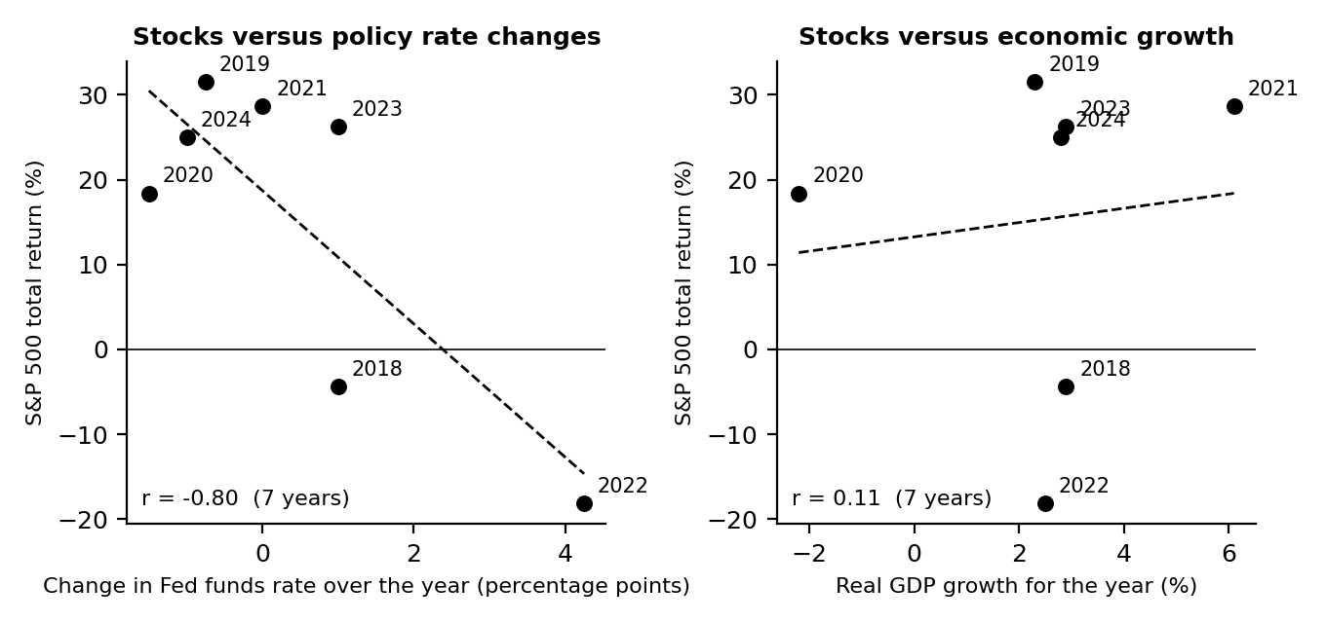
Figure 2. Annual S&P 500 total return against the change in the Fed funds rate and against real GDP growth, 2018 to 2024. Dashed lines are straight-line fits.
What the numbers say, and do not say. The change in the Fed funds rate has a strong negative correlation with stock returns (-0.80), and the change in the 10-year yield is also negative (-0.68). Real GDP growth (0.11), the level of inflation (-0.21) and the change in unemployment (-0.05) show essentially no link at all.
Two warnings keep me honest. First, seven observations is a tiny sample. With so few points, a correlation has to be around 0.75 or more in absolute size to be statistically significant at the usual 5% level, and only the policy rate result clears that bar (p = 0.03). Second, that result leans heavily on one year. Remove 2022, when the Fed raised rates by 4.25 points and stocks fell 18%, and the correlation with the policy rate drops to -0.41, and the one with the 10-year yield to -0.12. The rank correlations in the last column, which are less sensitive to extreme years, are also much weaker (about -0.4). So the safest reading is that rate shocks have hurt stocks when they were large and fast, and that growth, inflation and jobs data on their own do not explain annual returns. This fits the episode table: 2020 had the worst growth number of the period and one of the better stock returns.
There is a practical lesson in this. If the data does not predict returns directly, the useful question is what the data will make the Fed do, and whether that is already priced in.

7.3 Worked examples
Calculation | Working | Result and meaning
Effect of a higher discount rate on a far-away cash flow | $100 due in 10 years: 100 / 1.09^10 = $42.24 and 100 / 1.10^10 = $38.55 | -8.7%. A one point rise cuts the value of distant profits by almost 9%
The same for a near cash flow | $100 due in 2 years: 100 / 1.09^2 = $84.17 and 100 / 1.10^2 = $82.64 | -1.8%. Near-term profits barely care. This is why growth stocks are rate-sensitive
Real yield | 10-year yield 5.24% less CPI inflation 3.7% | About 1.54%
Real wage growth | Wage growth about 3.0% less CPI 3.7% | About -0.7%: pay is losing ground to prices
Forward earnings yield against the 10-year yield | S&P 500 forward P/E 19.0, so 1 / 19.0 = 5.26%. 10-year yield 5.24% | Difference of +0.02 points: stocks offer almost no extra yield over risk-free Treasuries
Trailing earnings yield against the 10-year yield | Trailing P/E 26.0, so 1 / 26.0 = 3.85%. 10-year yield 5.24% | Difference of -1.39 points
Core inflation, annual against recent pace | Annual core 2.6%; three-month annualised pace about 3.7% | Underlying inflation is running faster than the annual figure shows
Table 5a. Worked examples (FactSet for P/E, BLS for inflation, AP for yields).
The earnings yield comparison is the most striking line. When stocks yield about the same as safe government bonds, investors are relying on earnings growth to make up the difference, and FactSet analysts do expect it: 32.8% growth for the S&P 500 in 2026, slowing to 16.0% in 2027. If growth disappoints, there is little yield cushion.
Next, the correlation in Table 5 for the Fed funds rate, calculated by hand. Let x be the yearly change in the policy rate and y the S&P 500 return.
Year | x: change in Fed funds | y: S&P 500 return % | x minus mean | y minus mean | Product | Square of x deviation | Square of y deviation
2018 | 1.00 | -4.4 | 0.57 | -19.7 | -11.3 | 0.33 | 389.8
2019 | -0.75 | 31.5 | -1.18 | 16.2 | -19.0 | 1.39 | 261.1
2020 | -1.50 | 18.4 | -1.93 | 3.1 | -5.9 | 3.72 | 9.3
2021 | 0.00 | 28.7 | -0.43 | 13.4 | -5.7 | 0.18 | 178.4
2022 | 4.25 | -18.1 | 3.82 | -33.4 | -127.8 | 14.60 | 1,118.4
2023 | 1.00 | 26.3 | 0.57 | 11.0 | 6.3 | 0.33 | 120.1
2024 | -1.00 | 25.0 | -1.43 | 9.7 | -13.8 | 2.04 | 93.3
Sum |  |  |  |  | -177.3 | 22.59 | 2,170.3
Table 5b. Worked correlation. Means: x = 0.429, y = 15.34.
Correlation r = sum of products / square root of (sum of squared x deviations x sum of squared y deviations) = -177.3 / square root of (22.59 x 2,170.3) = -0.80. This matches Table 5. The table also shows why 2022 dominates: its x deviation (3.82) and y deviation (-33.4) give a product of -127.8, which is about 72% of the total.

8. Outlook for the Next Six to Twelve Months

8.1 The starting point
Item | Where things stand
Stock market | S&P 500 7,811.54 (9 Oct), up 14.1% for the year; Nasdaq Composite 27,366.17, up 17.7%; Russell 2000 up 13.1%. FactSet cites a closing level of 7,744.06 about a week later
Valuation | S&P 500 forward P/E 19.0 against a ten-year average of 19.1; S&P 500 earnings growth expected at 29.0% for Q3, 32.8% for 2026 and 16.0% for 2027 (FactSet, 16 Oct)
Business surveys | ISM Manufacturing PMI 54.5 in September (new orders 55.3, prices paid 77.9), the ninth straight month of expansion
Policy rate | 3.75% to 4.00%; median projection 4.1% at end-2026 and unchanged through 2027
10-year yield | About 5.24% on 9 Oct, the highest in more than two decades
Inflation | 3.7% headline, 2.6% core; gasoline up 34% over the year; Brent crude about $105 a barrel on 9 Oct
Labour market | Payroll growth about 51,000 a month over three months; unemployment 4.2%
Growth | US GDP 2.2% in Q2; IMF forecast 2.3% for 2026 and 2027
Next events | Fed meeting 27 and 28 Oct; Q3 GDP first estimate; October jobs report (early Nov); CPI for October (10 Nov); December Fed meeting
Table 6. Starting point as of mid-October 2026.

8.2 Scenarios
Scenario | What happens | Indicators to watch | Likely market effect
Base case (about 50%) | The Fed makes one more hike and then holds. Inflation stays near 3.5% and eases slowly. Growth near 2%. Payrolls stay weak but unemployment rises only slowly. | Core CPI near 0.3% a month; 10-year yield between 4.8% and 5.4%; unemployment below 4.6% | Range-bound index with wide gaps between sectors. Earnings support prices, but high yields cap valuations.
Soft landing (about 25%) | Energy prices fall as tensions ease. Inflation drops back toward 3%. The Fed stops and yields ease. | Gasoline falls; core CPI under 0.25% a month; 10-year yield falling below 4.8% | Rally in long-duration growth stocks and in small companies. Bond prices rise.
Stagflation scare (about 25%) | Oil spikes further, inflation exceeds 4% and the Fed hikes more than expected while hiring weakens. | Brent sustained above $115; CPI above 4%; payrolls turning negative; 10-year yield above 5.5% | Equity correction of 10% to 20%, hardest on expensive growth stocks. Stocks and bonds fall together.
Table 7. Scenarios. Probabilities are my own judgement, not market-derived.
The probabilities are only my judgement and I would change them as new data arrives. I put the base case at half because the IMF's own projection (growth near 2.3% with inflation easing in 2027) and the Fed's projections both point there, and I split the rest evenly because I cannot tell which of the two risks, a fall in energy prices or a further spike, is more likely.

8.3 Implications for investors
Area | Base case | Soft landing | Stagflation scare
Large technology | Neutral. Strong earnings against high real yields | Positive | Negative
Banks | Positive. Higher rates help net interest income, but credit costs are rising | Neutral | Negative on credit worries
Energy | Positive while oil stays high | Negative | Positive
Defensive sectors (health care, staples, utilities) | Neutral | Neutral | Relatively positive
Short-term bonds and cash | Positive. Yields near 4% to 5% | Positive | Positive
Long-term bonds | Neutral. Fall if yields rise further | Positive | Negative
Gold | Neutral | Neutral | Positive
Table 8. Direction of likely effect by scenario. These are qualitative judgements.
These tables connect directly to the earlier weeks. In Week 2, the DCF for Microsoft was very sensitive to the discount rate, and with the 10-year yield now about 0.2 points higher than the 5.0% I used, the base-case value falls by about 4% (to roughly $390 a share). In Week 3, JPMorgan's chart showed a pullback to support, while its results showed higher net interest income. And in Week 4, the case for a diversified portfolio looked stronger because stocks and bonds fell together in 2022, the scenario that looks most like the stagflation case above.

9. Limitations
- Revisions. GDP, payrolls and CPI are all revised, and the September GDP figure for the second quarter rose by 0.7 points after the first estimates.
- Small sample. The statistical check uses only seven years. It is an illustration of how to test a relationship, not strong evidence.
- Rounded history. The annual figures in Table 4 are rounded and drawn from standard series. They should be rechecked against the original sources before being relied on.
- Dates of market readings. Yield and index readings are for specific dates and have probably moved since.
- Scenario probabilities. They are my own judgement and are not forecasts.
- Geopolitics. I take the Middle East conflict and the energy price spike as given. A sudden change in either would alter the scenarios.
- Not advice. This is a learning exercise and not a recommendation to buy or sell any security.

10. Conclusion
The four indicators tell a story of an economy that is growing steadily while inflation and interest rates push the wrong way, and a stock market that has so far looked past it. History suggests that markets forgive weak data when policy is easing, and struggle when rates rise quickly. The Fed is raising rates now, and the 10-year yield is near its highest in two decades, so the safety margin for stocks is thinner than the record index levels suggest.
My base case is not a crash but a long grind: strong company earnings against high yields, with large differences between sectors. The most useful signals to watch are the energy price, the next two CPI reports and the Fed's decision on 28 October. In that setting, the practical conclusion for investors is the one from Week 4: spread risk, keep some defensive assets and avoid relying on one theme.

11. Sources
- US Bureau of Economic Analysis, "GDP (Third Estimate), Industries, Corporate Profits, State GDP, and State Personal Income, 2nd Quarter 2026", 30 September 2026: https://www.bea.gov/news/2026/gdp-third-estimate-industries-corporate-profits-state-gdp-and-state-personal-income-2nd
- NerdWallet, "Second Quarter GDP Revised Upward" (quarterly GDP history): https://www.nerdwallet.com/finance/learn/gdp-report
- International Monetary Fund, World Economic Outlook, October 2026 (media briefing): https://mediacenter.imf.org/news/imf---world-economic-outlook-annual-meetings--2026/s/22f94667-d194-473b-87b2-34c692b5a5a3
- Fortune, "Just 32 countries are driving 95% of global growth as the IMF warns of an increasingly uneven economy", 13 October 2026: https://fortune.com/2026/10/13/imf-global-growth-forecast-2026-ai-economic-divide/
- EUROMETAL, "IMF forecasts global economic growth to slow to 3.1 percent in 2026", 15 October 2026: https://eurometal.net/imf-forecasts-global-economic-growth-to-slow-to-3-1-percent-in-2026-amid-energy-price-pressures/
- US Bureau of Labor Statistics, Employment Situation, September 2026 (released 2 October 2026): https://www.bls.gov/ces/
- CNBC, "Labor market faltered in September as jobs increased by just 29,000", 2 October 2026: https://www.cnbc.com/2026/10/02/jobs-report-september-2026.html
- US Bureau of Labor Statistics, Consumer Price Index, September 2026 (released 14 October 2026): https://www.bls.gov/cpi/
- CNBC, "Consumer prices rose 3.7% annually in September as gas prices skyrocket", 14 October 2026: https://www.cnbc.com/2026/10/14/cpi-inflation-report-september-2026.html
- Federal Reserve, FOMC statement, 16 September 2026: https://www.federalreserve.gov/monetarypolicy/files/monetary20260916a1.pdf
- J.P. Morgan Asset Management, "FOMC Statement: September 2026": https://am.jpmorgan.com/us/en/asset-management/adv/insights/portfolio-insights/fixed-income/fixed-income-perspectives/fomc-statement-september-2026/
- CNBC, "10-year Treasury yield climbs back to 5% after Fed hikes rates", 16 September 2026: https://www.cnbc.com/2026/09/16/treasury-yield-bond-market-fed-decision.html
- Associated Press via La Nacion, "How major US stock indexes fared Friday 10/9/2026": https://www.lanacion.com.ar/usa/how-major-us-stock-indexes-fared-friday-1092026-nid09102026/
- Charles Schwab, "Fed Hikes: What's Next for Treasury Yields?": https://www.schwab.com/learn/story/fed-hikes-whats-next-treasury-yields
- S&P Dow Jones Indices, BEA, BLS, Federal Reserve and US Treasury historical series for Table 4: https://fred.stlouisfed.org

Week 6 Report: Investment Recommendation and Comprehensive Report
Companies: Microsoft Corporation (MSFT) and JPMorgan Chase & Co. (JPM)
Prepared by: Nayana Sheelavant Date: 19th October, 2026

1. Executive Summary
This is the final report of the internship. It pulls together the market research, financial statement review, technical analysis, risk assessment and economic analysis from the previous five weeks and turns them into a recommendation for two companies: Microsoft and JPMorgan Chase.
Microsoft is a business I admire at a price I cannot justify. Revenue grew 18% to $332 billion, operating margin is 46.8% and Azure has passed $100 billion in annual sales. But capital spending has swallowed the extra profit, so free cash flow fell to $67 billion, and the share price of $529.05 sits above even the base case of my valuation (about $406 at a 9.9% discount rate, and about $390 using today's higher yields). The price is close to my bull case and to a resistance zone of $540 to $555 that has stopped it before. My recommendation is Hold: keep what you own, and add new money only in stages at lower prices.
JPMorgan is a strong bank at a fair price, with a chart that is resting on support. Third-quarter net income was $15.3 billion, net interest income rose 13% and return on tangible equity was 20%. At about $336 the shares trade at 13.9 times 2026 earnings estimates and 3.0 times tangible book value, which is close to my fair value of about $328 and to Morningstar's $330. The price has pulled back about 11% from its August record to the 200-day average. My recommendation is Accumulate on weakness: buy in stages near $316 to $326, or after a close above $351.55.
 | Microsoft (MSFT) | JPMorgan Chase (JPM)
Recommendation | Hold. No new money above about $505 | Accumulate on weakness
Price used | $529.05 (16 Oct 2026 close) | About $336 (13 Oct 2026)
My fair value range | $247 to $538; base about $390 to $406 | About $282 to $360; central about $328
Why | Excellent business, thin cash flow, price needs the bull case | Strong earnings, reasonable price, support nearby
Main risk | AI spending that does not earn its return; a higher discount rate | Rising credit costs and slower capital markets income
Where I would add | $480 to $505, then $435 to $456 | $316 to $326, or above $351.55
Where I would rethink | Weekly close below $435 | Close below $315.70
Table 1. Recommendation summary.
Both recommendations sit inside the diversified framework from Week 4. Neither company should be more than about 5% of a portfolio, and the plan tells you what I would do if the economic backdrop from Week 5 turns worse.

2. How the Six Weeks Fit Together
Week | Question asked | Main finding carried into this report
1. Market analysis and research design | How should a sector be studied? | A hybrid method: macro first, then fundamentals, technicals, sentiment and scenarios. Technology was the sector.
2. Financial statements and valuation | What is Microsoft worth? | Excellent profitability, falling free cash flow and a DCF value below the share price.
3. Technical analysis | What is price doing? | Microsoft extended at resistance; JPMorgan correcting into support.
4. Risk and diversification | What can go wrong and how do we spread the risk? | A diversified portfolio cut risk by about 40% to 50% for a small cost in expected return.
5. Economic indicators | What does the economy say about markets? | Rates and inflation are the main pressure; a base case of range-bound markets.
Table 2. Summary of the earlier weeks.
I chose two companies because these are the two I could study through every lens across the weeks. They also behave differently: Microsoft is a growth company whose value depends on profits far in the future, and JPMorgan is a bank whose profits respond to rates and credit. A third holding would have meant new work in every section, and I preferred depth to breadth. I cover the rest of the portfolio at asset-class level in Section 8.

3. The Backdrop: Sector and Economy

3.1 Technology sector
In Week 1, I identified the main drivers of technology stocks: the AI spending cycle, interest rates, the concentration of index performance in a few large companies, and policy and supply risks. October 2026 data fits that picture. The S&P 500 and Nasdaq reached record highs in early October, with the Nasdaq Composite up 17.7% for the year, and market commentary put the AI chip group at the centre of the rally. At the same time the Dow was still about 5% below its August record in early October, and a major bank ETF was about 12% below its mid-August high, so leadership is narrow.

3.2 The economy (Week 5)
The economy is growing steadily but with warning lights. US GDP rose 2.2% in the second quarter, September payrolls rose only 29,000 and inflation reached 3.7% as gasoline prices rose 34% over the year. The Federal Reserve raised rates on 16 September to 3.75% to 4.00%, and the 10-year Treasury yield reached about 5.24% on 9 October, the highest in more than two decades. My base case is range-bound markets (about 50%), with a soft landing (about 25%) and a stagflation scare (about 25%) as the alternatives.
The main message for stock selection is that valuation matters more than usual. When a risk-free asset pays more than 5%, the price paid for each dollar of profit has less room to be generous. That favours businesses valued reasonably against their earnings, which is one reason the two recommendations differ.

4. Company One: Microsoft

4.1 Financial review
Microsoft's numbers, from the earnings release of 29 July 2026 and the earlier annual reports, are in Table 3.
($ billion unless stated) | FY2024 | FY2025 | FY2026
Revenue | 245.1 | 281.7 | 331.8
Operating income | 109.4 | 128.5 | 155.2
Operating margin | 44.6% | 45.6% | 46.8%
Net income | 88.1 | 101.8 | 133.7
Diluted EPS ($) | 11.80 | 13.64 | 17.95
Operating cash flow | 118.5 | 136.2 | 182.9
Capital spending | 44.5 | 64.6 | 115.9
Free cash flow | 74.1 | 71.6 | 67.0
Return on equity | n/a | 33.3% | 34.0%
Net cash (cash less debt) | 30.6 | 51.4 | 36.5
Table 3. Microsoft financial summary.
The business is extraordinary on every measure except one. Revenue growth of 18%, an operating margin near 47%, return on equity of 34% and a net cash balance all point to a company at the top of its game. The exception is free cash flow, which has gone down each year while profit has gone up. Capital spending reached 35% of revenue in FY2026, against 18% two years earlier. Net income was also helped by investment gains of about $10.7 billion in other income, so the operating story is a little less strong than the 31% headline growth suggests.

4.2 Valuation
Scenario | At a 9.9% discount rate | At 10.1% (10-year yield at 5.24%) | Versus $529.05 (second column)
Bear | $257 | $247 | -51% / -53%
Base | $406 | $390 | -23% / -26%
Bull | $538 | $516 | +2% / -3%
Weighted (25/50/25) | $402 | $386 | -24% / -27%
Table 4. Microsoft DCF values per share. The third column rebuilds the discount rate using the 10-year yield of 5.24% reported on 9 October; operating assumptions are unchanged from Week 2.
This table updates Week 2. I used a 5.0% risk-free rate there, based on mid-September yields. By 9 October the 10-year yield was 5.24%, so I reran the model, and every scenario fell by about 4%. The ordering of the conclusions does not change. At the current price, Microsoft is valued at roughly the bull case of my model.
Analysts are more optimistic, with price targets averaging about $599 and ranging from $440 to $870. Their numbers can be right if growth runs ahead of my base case or if yields fall. My model does not rule that out. It says the current price already assumes it, so the cushion for disappointment is small. Other measures agree: 29.5 times earnings, 59 times free cash flow and a free cash flow yield of 1.7%, against a risk-free yield above 5%.

4.3 Technical picture
The chart shows a sharp recovery of about 51% from the 24 June low of $349.20 to $529.05, with price above rising 50-day ($503.91) and 200-day ($434.78) averages and positive MACD momentum. The stock has run into a resistance zone of $540 to $555 for what looks like the third time. A close above about $555 on strong volume would be a bullish breakout. A close below the 50-day average near $504 would suggest the ceiling has held. It is constructive, but extended.

4.4 Risks
Risk | Why it matters | What would show it is happening
AI spending without returns | Capital spending is about a third of revenue and depreciation is rising | Capex guidance up while Azure growth slows; free cash flow falling further
Higher discount rates | A growth company is sensitive to the 10-year yield | Yield sustained above about 5.5%
Event risk | Earnings and the Fed decision both land on 28 October | A large gap down or up through $504 or $555
Concentration of the AI trade | The rally is led by a small number of stocks | Narrowing market breadth
Investment gains reverse | OpenAI and Anthropic stakes add volatility to reported profit | Large investment losses in other income
Table 5. Microsoft risks.

4.5 Conclusion on Microsoft: Hold
The business deserves a place in a long-term portfolio. The price today does not give a margin of safety. If you own it, keep it, and if it has grown past about 5% of the portfolio, trim it back. If you do not own it, I would not buy at this level. I would build a position in stages on a pullback: a first third in the $480 to $505 zone around the 50-day averages, and a second third in the $435 to $456 zone around the 200-day averages. I would reassess after the 28 October results, where capital spending guidance matters most.

5. Company Two: JPMorgan Chase

5.1 Financial review
JPMorgan reported third-quarter results on 13 October 2026. Banks are different from technology companies. Revenue comes mostly from net interest income (the gap between what it earns on loans and pays on deposits) and from fee and trading businesses, and the key risks are credit losses and capital strength.
Item | Q3 2026 | Comment
Net income | $15.3 billion, up 6% | $15.8 billion excluding a $658 million securities loss
Diluted EPS | $5.57, up 10% (from $5.07) | $5.75 excluding the loss; estimates were roughly $5.9
Net revenue | $50.9 billion, up 8% | Net interest income $27.1 billion, up 13%; fee revenue $23.8 billion, up 3%
Expenses | $27.3 billion, up 12% | Hiring, wages and revenue-linked pay
Credit costs | $2.7 billion | $2.2 billion net charge-offs and a $539 million reserve build
Return on tangible equity | 20% (21% excluding the loss) | Very high for a bank
Book value / tangible book value per share | $132.30 / $112.64 | Up 6% and 7% over the year
Capital | CET1 ratio 13.9% | Well above regulatory minimums
Shareholder returns | Dividend $1.65 per share; $664 million net buybacks | Buybacks reduced to prioritise lending growth
Outlook | Fourth-quarter net interest income about $28 billion | Management more selective on credit
Table 6. JPMorgan third-quarter 2026 highlights. Source: JPMorgan Chase earnings release (Form 8-K) and earnings call.
Earnings were good but not perfect: earnings per share missed expectations, the first miss since late 2023, because of an investment securities loss. Underneath, the results were strong. The Corporate and Investment Bank earned $8.2 billion (up 20%), consumer banking $5.7 billion (up 13%) and asset and wealth management $1.8 billion (up 11%). The weaker points are costs, which are growing faster than revenue, and credit, where management said it is becoming more selective and is watching risks from high interest rates, AI-related financing and market volatility. Morningstar noted that markets revenue, though 15% higher than a year ago, fell 15% from the second quarter, so the exceptional pace of the first half is fading.

5.2 Valuation
Banks are usually valued against tangible book value. A common approach ties the right multiple to profitability: fair price to tangible book equals (return on tangible equity minus growth) divided by (cost of equity minus growth). I assumed growth of 4%, a return on tangible equity between 17% and 21%, and a cost of equity between 9% and 11%. JPMorgan's tangible book value per share is $112.64.
Cost of equity \ ROTCE | 17% | 18% | 19% | 20% | 21%
9% | $293 | $315 | $338 | $360 | $383
10% | $244 | $263 | $282 | $300 | $319
11% | $209 | $225 | $241 | $257 | $274
Table 7. Value per share from tangible book value, growth of 4%.
My central case uses a 20% return (the reported level), a 9.5% cost of equity and 4% growth. That gives a multiple of 2.91 times tangible book, or about $328 a share. The grid shows how sensitive this is: the price of $336 needs roughly a 9% cost of equity with a 19% return, or a 20% return with a cost of equity around 9.3%. A cross-check on earnings gives a similar answer. At 12 to 16 times the 2026 estimate of $24.13 (a consensus figure from before the results), the range is $290 to $386, and the shares trade at 13.9 times. Morningstar's fair value is $330 and the pre-earnings consensus target is $372. The shares also yield about 2.0% in dividends.
Put together, JPMorgan looks fairly valued: not cheap, but priced for continued strong profitability, not for perfection.

5.3 Technical picture
JPMorgan has been in an ascending channel since the April 2025 low of $202.16. It hit a record of $366.50 on 13 August, then pulled back about 11% to $325.87 on 1 October, stalling at the 200-day average (about $322 to $325) and a 61.8% Fibonacci retracement. RSI of about 60 and a slightly positive MACD are neutral to firm. Short-term averages ($337 to $352) still sit above the price. A close above $351.55 would confirm that buyers are back; a close below about $321 would break the channel and point to $315.70.

5.4 Risks
Risk | Why it matters | What would show it is happening
Rising credit costs | Higher rates and inflation strain borrowers; credit costs were already $2.7 billion | Net charge-offs and reserve builds above Q3 levels for two quarters
Capital markets slowdown | Markets and investment banking revenue were unusually strong early in 2026 | Further quarter-on-quarter declines in markets revenue and fees
Cost growth | Expenses are up 12%, ahead of 8% revenue growth | Margin and return on tangible equity falling below 18%
AI-related financing | Management flagged it as a risk to monitor | Losses or stress in lending tied to data centres and AI
Rate path | Higher rates help interest income but can hurt credit and securities values | Yields rising sharply; the September securities loss recurring
Table 8. JPMorgan risks.

5.5 Conclusion on JPMorgan: Accumulate on weakness
This is a high-quality franchise that is reasonably priced. The chart and the valuation both say the best entry is on weakness, not on strength. I would buy a first half of the intended position in the $316 to $326 zone (the 200-day averages and the pivot support), and the second half after a close above the 50-day average at $351.55 shows that the correction is over. If the stock closes below $315.70, I would stop and reassess.

6. Putting the Two Side by Side
 | Microsoft | JPMorgan
Business quality | Very strong: operating margin 46.8%, ROE 34% | Very strong: ROTCE 20%, CET1 13.9%
Growth | Strong: revenue +18%, Azure +41% | Solid: revenue +8%, net interest income +13%
Cash and capital | Weakening: free cash flow down 6.5% on heavy capex | Sound, but buybacks cut and costs rising
Valuation | Stretched: 29.5x earnings; DCF base below price | Fair: 13.9x 2026 estimates; about 3.0x tangible book
Technical | Constructive but extended at $540 to $555 | Neutral; correcting into support at $316 to $326
Sensitivity to the economy | High: long-duration growth stock; 10-year yield above 5% | Mixed: higher rates help income but raise credit risk
Main risk | AI spending that does not earn its return | Credit costs and a capital markets slowdown
Recommendation | Hold | Accumulate on weakness
Table 9. Integrated scorecard.
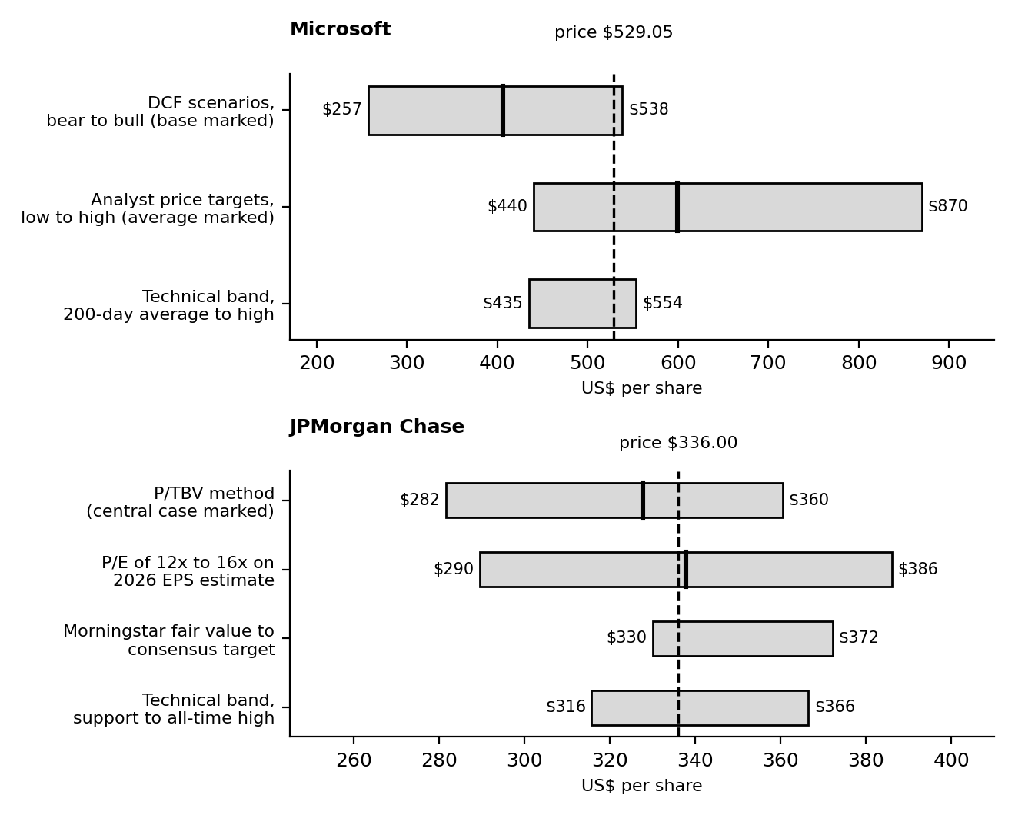
Figure 1. Valuation and technical ranges compared with the current share price for each company. The dashed line is the price; thick marks show central or average values.
The chart makes the difference plain. Microsoft's price sits at the top of my valuation range and inside a technical band with limited room above it. JPMorgan's price sits in the middle of its ranges, with support below and the record high above.

7. Risk Assessment for the Recommendations
Week 4 showed that the risk in a portfolio comes less from any single company than from how much of the portfolio moves together. Microsoft and JPMorgan are different kinds of businesses but both would fall in a broad stock market sell-off, and both have a link to interest rates. The table shows how each would be expected to behave in the three scenarios from Week 5.
Scenario (Week 5) | Microsoft | JPMorgan | What I would do
Base case (about 50%): range-bound market | Flat to slightly lower; valuation caps gains | Steady; earnings support the price | Follow the staged plan in Table 11
Soft landing (about 25%): energy falls, Fed stops | Positive; lower yields help a growth stock | Neutral to positive; credit stays benign | Let the plan run; Microsoft may not pull back, so accept a smaller position
Stagflation scare (about 25%): oil and inflation rise | Negative; the most exposed to higher yields | Negative on credit worries, partly offset by interest income | Pause new buying, hold the defensive sleeves of the portfolio
Table 10. Behaviour by scenario. These are qualitative judgements.
Using the Week 4 results as a guide, a concentrated technology portfolio lost about 27% in the 2022 rate-shock scenario against about 16% for the diversified one, and about 32% in my hypothetical AI-unwind scenario against about 16%. That is why neither company should be a large part of the portfolio, however good it looks.

8. Recommendations and Action Plan

8.1 Rating scale
Rating | Meaning
Buy / Accumulate | Price is at or below fair value with acceptable risk. Build a position in stages.
Accumulate on weakness | Fair value is close to the price. Add only at stated lower prices or after confirmation.
Hold | Keep existing holdings. Do not add at current prices.
Reduce / Sell | Price is well above fair value or the thesis has broken.
Table 11. Rating definitions used in this report.

8.2 Position sizing
I use the Week 4 hypothetical US$100,000 diversified portfolio as the frame. In that portfolio, technology is 15% ($15,000) and US broad equity is 30% ($30,000). A single stock should be capped at about 5% ($5,000). So Microsoft can be at most about $5,000, which is about a third of the technology sleeve, with the rest in a technology index fund. JPMorgan can be up to about $4,000 to $5,000 as part of the equity holdings, noting that the S&P 500 fund already holds some of both companies.

8.3 Action plan
Step | Microsoft | JPMorgan
Today | Hold existing shares. Do not add above about $505. | Buy nothing yet at about $336; wait for the stated zones.
First purchase | About one third of target ($1,500 to $1,700) at $480 to $505 after the 28 October results. | About half of target ($2,000 to $2,500) at $316 to $326.
Second purchase | Another third at $435 to $456. | The other half after a close above $351.55.
Alternative (momentum) | A weekly close above about $555 on heavy volume allows a third of the position, accepting a richer price. | Not needed.
Trim | If the holding exceeds 5% of the portfolio. | If the holding exceeds 5% of the portfolio.
Rethink | Weekly close below $435, or capex rising while Azure growth falls well below recent rates. | Close below $315.70, or credit costs well above $2.7 billion for two quarters.
Next review | After 28 October earnings; then January 2027 results. | After the fourth-quarter results in January 2027 (expected).
Table 12. Action plan. Price levels are from the Week 3 and Week 6 analysis.

8.4 Portfolio-wide triggers from the economic analysis
Trigger | Current | If it happens
10-year Treasury yield | About 5.24% (9 Oct) | Sustained above about 5.5%: pause new buying and review the technology weight
US CPI inflation | 3.7% (September) | Above 4%: raise inflation-linked bonds and cash within the Week 4 limits
Brent crude | About $105 (9 Oct) | Sustained above about $115: treat the stagflation scenario as the base case
Monthly payrolls | +29,000 (September) | Negative readings: expect the Fed to turn and review defensive holdings
Fed policy | 3.75% to 4.00%; one more hike expected | More hikes than projected: reduce expensive growth exposure
Table 13. Review triggers. These thresholds are my own, not market facts.

8.5 Calendar
Date | Event
27 and 28 October 2026 | Federal Reserve meeting
28 October 2026 | Microsoft fiscal first-quarter results
Early November 2026 | US October jobs report; US midterm elections
10 November 2026 | US CPI for October
December 2026 | Federal Reserve meeting
January 2027 (expected) | JPMorgan and Microsoft results
Table 14. Dates to watch.

8.6 Worked examples
Calculation | Working | Result
Microsoft probability-weighted value | 0.25 x $256.7 + 0.50 x $406.2 + 0.25 x $538.4 | $401.9
Microsoft weighted value against the price | $401.9 / $529.05 - 1 | -24.0%
JPMorgan fair multiple of tangible book | (20% - 4%) / (9.5% - 4%) | 2.91x
JPMorgan central fair value | $112.64 x 2.91 | $327.7
JPMorgan price against fair value | $336.00 / $327.7 - 1 | +2.5%
JPMorgan current multiple of tangible book | $336.00 / $112.64 | 2.98x
JPMorgan dividend yield | 4 x $1.65 / $336.00 | 1.96%
Table 11a. Valuation calculations.
Reference value | Amount | Versus price
Microsoft, base DCF (9.9% discount rate) | $406 | -23.2%
Microsoft, weighted DCF at 10.1% | $386 | -27.1%
Microsoft, bull DCF (9.9%) | $538 | +1.8%
Microsoft, average analyst target | $599 | +13.2%
JPMorgan, P/TBV central value | $328 | -2.5%
JPMorgan, 14 times 2026 EPS of $24.13 | $338 | +0.5%
JPMorgan, Morningstar fair value | $330 | -1.8%
JPMorgan, consensus target (pre-earnings) | $372 | +10.8%
Table 11b. How far each reference value is from the current price.
Read together, every one of my own Microsoft values is below the price and only the analyst target is above it, which is why the rating is Hold. For JPMorgan the reference values straddle the price, from about 2% below to about 11% above, which is what a fairly valued stock looks like and why the plan relies on buying lower or after confirmation.
Staged entry | Working | Average cost
Microsoft, thirds at $495 and $445 (zones from Table 12) | ($495 + $445) / 2 | $470 for two thirds of the position, 11.2% below $529.05
Microsoft, adding a breakout third at $556 | ($495 + $445 + $556) / 3 | $498.67 for the full position
JPMorgan, halves at $321 and $352 (zone and confirmation level) | ($321 + $352) / 2 | $336.50, almost the same as today's price but with the confirmation of a close above the 50-day average
Table 12a. Average cost of staged entries.
The JPMorgan example shows the real value of the staged plan. The average cost equals today's price, but the second half is only bought once the chart has proved the correction is over, so money is committed with better information. For Microsoft, waiting for the first zone means paying about 6.4% less than the current price ($495 against $529.05) before any other benefit.

9. What Would Change My Mind
- For Microsoft: free cash flow turning up as capital spending flattens, together with Azure growth holding near 40%, would make the bull case more credible and justify a higher fair value. A fall in yields would do the same. Conversely, a failed breakout above $555 followed by a close below $504 would make me more cautious.
- For JPMorgan: a close above $351.55 would bring the second half of the position forward. A rise in credit costs together with weaker markets revenue would make me reconsider even at lower prices.
- For the plan overall: a sudden energy price spike, a hawkish Fed surprise or a sharp fall in hiring would all move me toward the defensive end of the Week 4 portfolio.

10. Limitations and Disclosures
- Models are assumptions. The DCF and bank valuation depend heavily on discount rates and growth. Small changes move the results by tens of dollars a share, and the tables show this.
- Dated information. Prices and indicators are from the dates stated. Microsoft reports on 28 October, and the picture could change quickly.
- JPMorgan price. I used about $336, the latest price I could verify (13 October). The consensus earnings estimate of $24.13 and the $372 target were published before the third-quarter results.
- Technical levels are judgement. Support and resistance are zones, not exact lines, and different data providers sometimes give slightly different averages.
- Two companies only. Two stocks cannot show how a whole portfolio behaves. The portfolio-level view comes from Week 4.
- No positions held. I hold no positions in either company.
- Not investment advice. This report is a learning exercise prepared for an internship. It is not a recommendation to buy or sell any security, and readers should do their own research or speak to a licensed adviser.

11. Conclusion
The central finding of the six weeks is that a good company and a good investment are two different things, and that the difference is the price. Microsoft has the better business growth and the stronger charts of the past year, but its price already counts on a bright future, and the recent fall in free cash flow shows the cost of building it. JPMorgan is a less exciting business with a fairer price and a chart that is resting at support.
So my plan is patient. Hold Microsoft and add only at lower prices, accumulate JPMorgan in stages near support, keep each name small, and let the Week 4 portfolio rules and the Week 5 triggers say when to be more careful. If the market proves me too cautious on Microsoft, the cost is a smaller position. If it proves me right, the lower prices become the entry point.

12. Sources
- Microsoft Corporation, Form 8-K, Exhibit 99.1, 29 July 2026: https://www.sec.gov/Archives/edgar/data/0000789019/000119312526323632/msft-ex99_1.htm
- Yahoo Finance, Microsoft (MSFT) quote, 16 October 2026: https://finance.yahoo.com/quote/MSFT/
- JPMorgan Chase & Co., Form 8-K, Exhibit 99.1, third-quarter 2026 earnings release narrative: https://www.sec.gov/Archives/edgar/data/0000019617/000162828026065582/a3q26erfexhibit991narrative.htm
- Pulse 2.0, "JPMorgan Chase Reports $15.3 Billion Q3 Profit As Revenue Rises 8%": https://pulse2.com/jpmorgan-chase-q3-2026-results/
- MarketBeat, "JPMorgan Chase & Co. Q3 Earnings Call Highlights", 13 October 2026: https://www.marketbeat.com/instant-alerts/transcript-jpmorgan-chase-co-q3-earnings-call-highlights-2026-10-13/
- Morningstar, "JPMorgan Earnings: Solid Results Despite Capital Markets Softening": https://www.morningstar.com/stocks/jpmorgan-earnings-solid-results-despite-capital-markets-softening
- Beinsure, "JPMorgan Chase stock forecast: earnings miss, 2027 outlook": https://beinsure.com/news/jpmorgan-chase-stock-forecast-earnings-miss/
- OANDA, "JPMorgan Q3 Earnings Preview": https://www.oanda.com/sg-en/skills-and-insights/education/trading-asset-classes/shares/jpmorgan-q3-earnings-preview/
- AlgovestIQ, MSFT technical analysis: https://www.algovestiq.com/stock/msft/technicals
- Associated Press via La Nacion, "How major US stock indexes fared Friday 10/9/2026": https://www.lanacion.com.ar/usa/how-major-us-stock-indexes-fared-friday-1092026-nid09102026/
- Investrade, "Daily Market Report, October 7, 2026": https://investrade.com/?p=1601
- US Bureau of Labor Statistics, Employment Situation and Consumer Price Index, September 2026: https://www.bls.gov/cpi/
- US Bureau of Economic Analysis, GDP (Third Estimate), 2nd Quarter 2026: https://www.bea.gov/news/2026/gdp-third-estimate-industries-corporate-profits-state-gdp-and-state-personal-income-2nd
- Federal Reserve, FOMC statement, 16 September 2026: https://www.federalreserve.gov/monetarypolicy/files/monetary20260916a1.pdf
- International Monetary Fund, World Economic Outlook, October 2026: https://mediacenter.imf.org/news/imf---world-economic-outlook-annual-meetings--2026/s/22f94667-d194-473b-87b2-34c692b5a5a3
- Weeks 1 to 5 of this internship report series (author's own work).

